**Transit-Oriented Discoveries: Data-Driven Insights into U.S. Urban Landscapes**

David Schneider

Capstone Paper for DA 591: “Data Analytics Practicum”

Catholic University of America School of Engineering

May 3, 2024

**1. Abstract**

This research investigates the extent and characteristics of Transit Oriented Development (TOD) across the United States by leveraging open data sources and analytics. The study aims to uncover patterns in land use, urban form, transportation networks, and amenities within accessible distances from these stations. Utilizing recent datasets from the Federal Transit Administration’s National Transit Database, OpenStreetMap, and the Census Bureau, the research addresses a significant gap in national-level TOD analysis, offering fresh insights since the last comprehensive study a decade ago. The core research questions explore the presence and extent of dense, walkable, and mixed-use developments around rail stations and identify key factors contributing to high levels of TOD. Through a combination of exploratory data analysis, feature creation, and advanced clustering techniques, the study will classify station areas by their TOD characteristics and assess changes in local demographics and infrastructure.

**2. Background**

Transit-Oriented Development (TOD), defined as dense, walkable, mixed-use development near transit stations, offers many benefits (FN). By locating housing and businesses near transit, TOD has the potential to reduce people’s need to travel by car, which in turn lessens traffic congestion, air pollution, and greenhouse gas emissions. TOD promotes economic growth through increased local tax revenue and additional housing options near transit facilities, which may be especially attractive to non-drivers such as older adults, people with disabilities, low-income individuals, and students. Moreover, TOD helps reduce suburban sprawl and provides more "eyes on the street," thereby improving public safety. The presence of more accessible destinations promotes physical activity among residents, generates job opportunities, and can foster a strong sense of place and community cohesion. Overall, TOD is pivotal in shaping urban areas that are more efficient, environmentally friendly, and inclusive, making it an essential approach in contemporary urban planning.

Implementing TOD presents challenges, prompting questions about simplifying processes, adapting strategies for different locales, and addressing community concerns. Ensuring transportation infrastructure keeps pace with new development is also critical. Additionally, equity issues necessitate discussions on where TOD takes place, housing affordability near transit, and the potential for gentrification and displacement. Addressing these concerns effectively is essential for the success and acceptance of TOD initiatives.

In this context, leveraging data and analytics becomes essential as they empower stakeholders to learn from past implementations, collaborate effectively, target scarce resources, and make informed decisions. This proactive approach ensures that TOD initiatives are tailored to meet the unique needs of each community, fostering sustainable urban growth while addressing potential challenges head-on.

**3. Research Goals, Questions, and Potential Uses**

This research creates new knowledge through a comprehensive database that includes land cover, land uses, and transportation features around transit stations. This database aims to address several pivotal research questions. It will investigate the prevalence of Transit-Oriented Development (TOD), identifying areas with significant or minimal TOD implementation. Additionally, it will explore the potential for further TOD expansion and determine the locations with the greatest opportunities. The project seeks to understand if station areas can be meaningfully segmented by their characteristics, assess the impact of TOD on home values and rents, and examine whether TOD is more prevalent in racially and ethnically diverse communities or predominantly white areas.

The research is designed to produce end products that will serve immediate and long-term purposes. In the short term, the project will culminate in a series of progress presentations, a final presentation, and a comprehensive final paper for DA 591 (Data Analytics Practicum). For the long term, outputs may include a GitHub repository containing the data and code, a Kaggle dataset, and potentially a website offering visuals, maps, and data on transit stations across the United States.

This project’s data and analytics can be used as a screening tool and a foundation for further practical applications. Real estate developers might use the project’s features for market research and to pinpoint promising or overlooked development opportunities. Local governments could leverage the data to prioritize pedestrian and bike safety improvements or to reassess zoning and parking regulations near transit stations. Transportation planners might utilize the results to plan new routes or station locations. Additionally, the database could support advocates of smart growth and affordable housing, provide academics with a basis for extended research on TOD, assist transit agencies in peer-to-peer analysis, and help individuals in choosing places to live or establish businesses.

**4. Data Sources**

This project uses the following data sources:

**4a. Transit Station and System Data**: This data source includes information from the National Transit Database, 2022 Facilities Inventory, which includes validated data from the calendar year 2022 and published in November 2023 It is publicly accessible and can be found online at the National Transit Database website: <https://www.transit.dot.gov/ntd/data-product/2022-annual-database-facility-inventory>. This dataset is updated annually and usually published in the fall.

**4b. OpenStreetMap (OSM) Land Use and Transportation Data:** OpenStreetMap is a dynamic and editable map of the world. It began as a collaborative open data project in 2014 and is maintained by volunteers. This map is widely used in various applications and software, reflecting a collective effort to document global land use and transportation features. (While the data is free and comprehensive, it is subject to potential errors, both intentional and unintentional. It’s completeness varies by location with more accurate data in more populous areas) This source provides essential geographical insights that are instrumental in analyzing the spatial aspects of transit-oriented developments. Additional information is at [www.OpenStreetMap.org](http://www.OpenStreetMap.org)

**4c. Census Geographic Data**: The Census Bureau's Master Address File/Topologically Integrated Geographic Encoding and Referencing (TIGER) system provides digital representations of geographic features such as lakes, landmarks, roads, and boundaries. These shapefiles, which include data from the 2010 and 2020 Census for blocks and block groups, are fundamental for creating detailed maps that aid in the spatial analysis of demographic, economic, and developmental patterns, particularly in the context of studying transit-oriented developments and their impacts on communities. See <https://www.census.gov/geographies/mapping-files/time-series/geo/tiger-line-file.html>.

**4d. Census Demographic Data: Race and Ethnicity:** This project uses data derived from the 2010 and 2020 Decennial Census at the block level, specifically from Census Table P9, which categorizes the population by Hispanic or Latino and Not Hispanic or Latino by race. The data is segmented further into detailed racial groups including White alone, Black or African American alone, American Indian and Alaska Native alone, Asian alone, Native Hawaiian and Other Pacific Islander alone, Some Other Race alone, and individuals of two or more races. This data allows analysts to better understand the racial and ethnic composition of transit-oriented development areas, assessing whether TOD initiatives are occurring in racially and ethnically diverse communities or are more concentrated in homogenous communities. This data is accessible by querying <https://data.census.gov/>.

**4e. Census Demographic Data: Home Values and Rents:** Leveraging data from the American Community Survey (ACS), specifically the 2013 and 2022 5-rolling survey results at the block group level, the project examines housing economic variables using Table B25077 for Median Home Value and Table B25064 for Median Gross Rent. This data provides insights into the economic landscape of neighborhoods, including housing affordability and market trends. Understanding the median home values and rents near transit stations is important for evaluating the economic impact of transit-oriented developments, particularly in terms of housing affordability, gentrification, and displacement risks. This data is also available at <https://data.census.gov/>. ACS surveys are typically updated and published annually.

**5. Project Timeline**

This project started with foundational work in Fall 2023 and Winter 2024. During this period, I developed scripts for querying OpenStreetMap and Census data and looking up images of transit station areas. I also pilot tested the analysis using 91 Washington Metropolitan Area Transit Authority (WMATA) rail stations and shared the initial results with colleagues at the U.S. Department of Transportation and at a conference in January.

I structured my project in the Spring semester around weekly tasks. Starting from the first week of January, I pulled data from OpenStreetMap and the Census, continuing this through the second week. The next two weeks focused on data wrangling, cleaning, and quality analysis to prepare the data for deeper exploration. From the fifth week, I begin exploratory data analysis, progressively focusing on different aspects such as transit stations, land uses, and transportation features. By mid-semester, I engaged in more complex analyses like clustering, calculating Transit-Oriented Development (TOD) scores, and assessing TOD potential, culminating in the midterm presentation. My final two weeks are dedicated to applying statistical methods to explore changes in population, housing, rent, and demographics, culminating in a comprehensive final presentation at the end of the semester. This structured approach ensures systematic progress through various project phases, leading to insightful findings and conclusions.

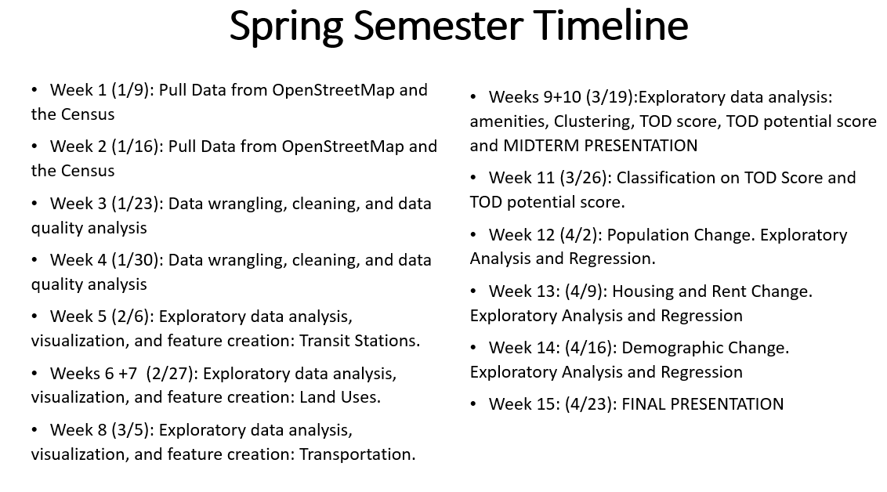

**6. Data Wrangling and Extraction**

**6a. National Transit Database Data:** I started by filtering the transit station data from the National Transit Database Facilities Inventory and removing stations with duplicate information (duplicates usually occurred when a transit agency coded two platforms in the same station as separate facilities, however my analysis treats these as a single facility). Using Google Earth Engine, I geocoded missing coordinates and addresses and generated County information from these coordinates. I also created a GeoJSON file with a quarter-mile circular buffer around each station's coordinates and grouped the stations into different transit system categories based on research and domain knowledge. The output include almost 4,000 records along with attributes such as facility ID, name, coordinates, transit agency details, and the type of transit facility. The specific data outputs are shown in the table below and definitions can be found in the data dictionary included along with the .csv file.

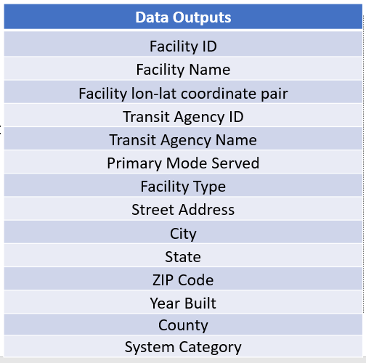

**6b. OpenStreetMap Land Cover/Land Uses**: I selected specific land features I considered to be most relevant to analyzing TOD and I developed a function to query the OpenStreetMap Application Programming Interface (API) for areas within a circle with a quarter-mile radius around the stations. The function calculates the area covered by the selected features and counts the number of buildings. I iterated through the station data from the NTD dataset to collect building counts and land area associated with the features shown in the table below. This method allows for a detailed analysis of land use near transit stations. The specific data outputs are shown in the table below:

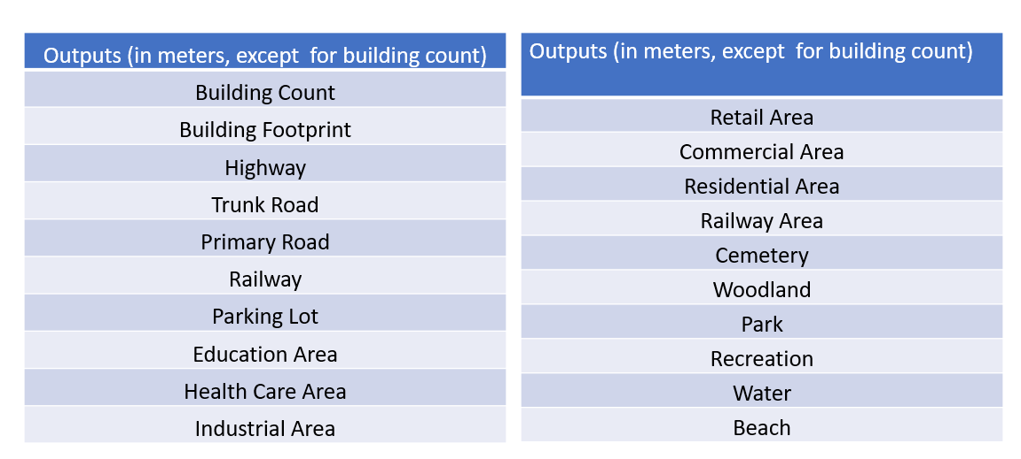

**6c. OpenStreetMap Street Network Features**: I extracted street network features from OpenStreetMap by creating a function that queries the OSM API for areas within a circle with a quarter mile around the stations. This function calculates the total number of intersections, street segments, the average length of these segments, and the number of sidewalks and footways in the area. I collected these data points for each station and compiled them into a CSV file, providing a comprehensive view of the street network around transit stations.

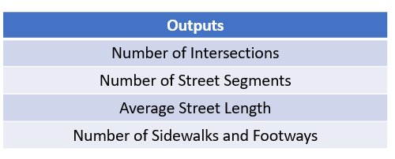

**6d. OpenStreetMap Amenities**: I chose fifteen specific amenities from OpenStreetMap that I determined to be most relevant to TOD and created a function to query the OSM API and count the number of amenities within a quarter-mile radius of the stations. I looped through the station data to collect counts of amenities in each category and recorded these in a CSV file. This process created two datasets, one with binary data on amenities by category (assigning a 1 if one or more amenitiy in each category is present and 0 if not) and a second with the total number of amenities in each category. For example, a station that includes three nearby grocery stores would be associated with a “1” in the first output file for the presence of a grocery store and a “3” in the second output file for the actual number of stores in the catchment area. This approach helped me quantify the types of amenities available around transit stations, improving our understanding of the services accessible to transit users and people living near the stations.

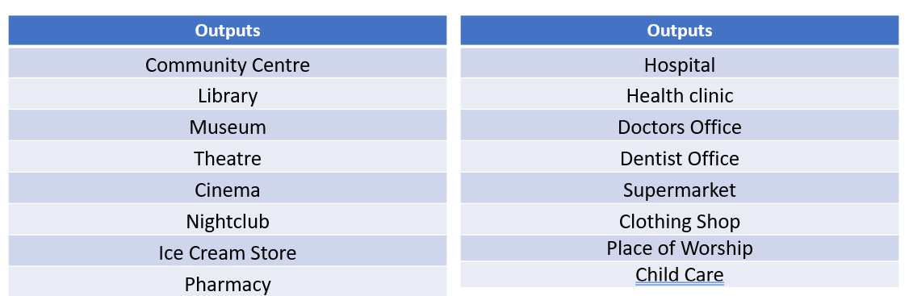

**6e. Station and Census Shapefile Joins:** I conducted spatial joins (a method used to combine data from two different sources based on a common geographic attribute) using the GeoJSON file described in section 6a and the 2020 TIGER/Line files for census blocks and block groups. I also repeated these joins for the 2010 TIGER/Line files. The resulting data allowed me to align transit station data with relevant census data, thus enabling detailed demographic and housing analysis at and around these stations. The data outputs from these joins included population and housing units for both 2020 and 2010, available at the block level and aggregated to the transit station area level, providing a comprehensive snapshot of the areas surrounding each transit station. A visual of these joins as well as the data outputs are shown below:

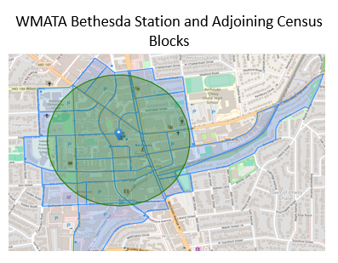 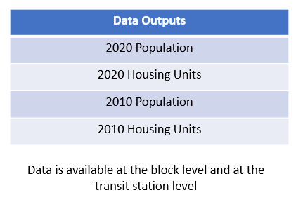

**6f. Census Shape File and Housing Value/Rent Price Joins**: Using methods similar to those described in section 6e, I joined Census block groups around stations with American Community Survey data on median home values and median rents. To derive a more representative metric across various block groups, I calculated the mean of these medians, not weighted by the population of block groups and excluding areas where data were unavailable. The outputs include the median home values and rents for both 2020 and 2010, giving insights into housing economics at the block group and transit station area levels. This approach helps assess how housing costs have evolved in transit-oriented areas over the decade. A visual of these joins for median home value as well as the data outputs are shown below:

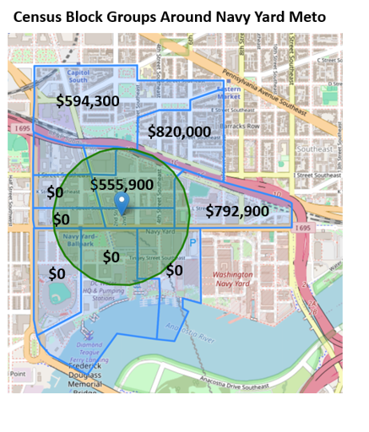 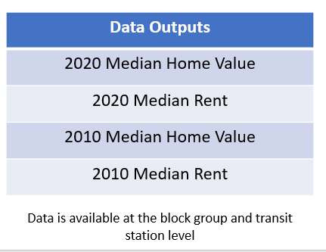

**6g. Census Shapefile and Race/Ethnicity Joins**: I joined census blocks around stations with 2020 and 2010 race and ethnicity data. This method allowed me to capture comprehensive demographic profiles at the block level and aggregate them to the station area level in order to analyze demographic changes over time. A visual of these joins as well as the data outputs are shown below

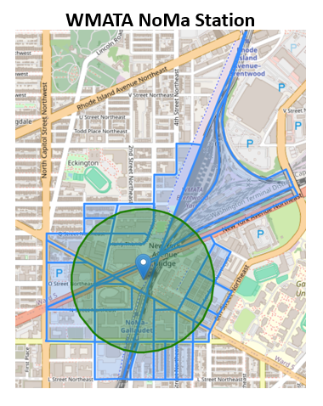 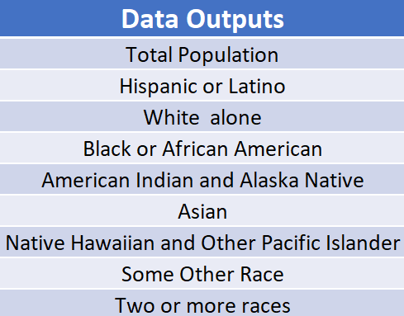

**6h. Entity-Relationshup Model.** The diagram below encapulates all of the data sets used in this project, which forms an initial set of 3,947 records (one for each feature) and 68 features from the NTD, OpenStreetMap, and the Census. Some records were removed during subsequent quality control (see Part 8) and additional features were created during the feature engineering phases of my project (See Part 9).. Each rectangle in the diagram below is represented by at least one CSV file which includes a unique, four-digit station ID included in the NTD data as the primary key.

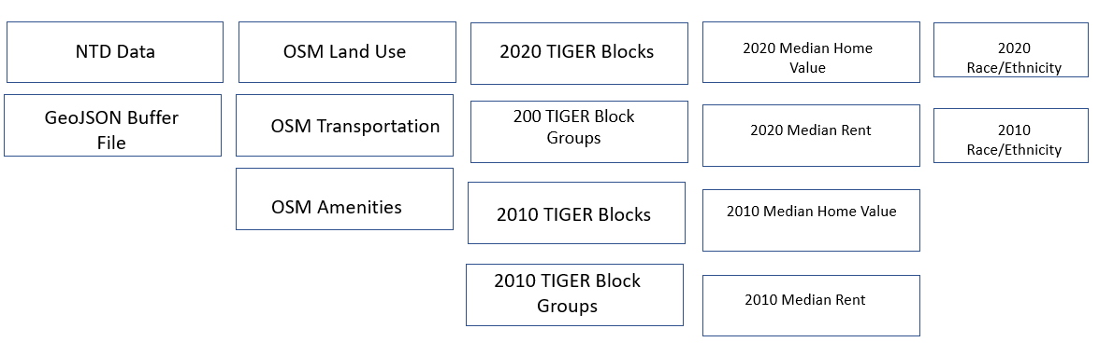

**7. Creating Analytics Tools and Managing Data**

I developed a data visualization tools using Python in order to visualize station areas and to plot station locations relative to one another. These tools allowed me to conduct visual inspections of station areas overlayed on OpenStreetMap data in order to double check the information in my tabular files as needed. The table below is a screen shot of a Python script I created in order to enter the unique ID of each station (in this case, the Dallas Area Rapid Transit (DART) Downtown Irving/Heritage Crossing Station) and generate the corresponding visual.

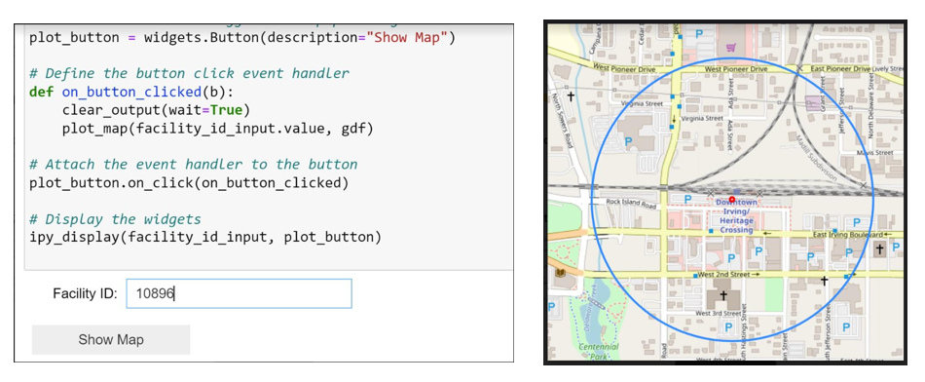

To manage data effectively, I created a Google Cloud console and implemented protocols to prevent data loss, facilitate swift retrieval, and ensure accurate version control. This setup not only preserves the integrity of the data but also fosters transparency and reproducibility in my research methodologies, setting a precedent for future research endeavors.

**8. Data Quality Challenges and Mitigations**

All data analytics projects (with the possible exception of those using toy datasets) involve data quality challenges and require methodological choices and mine is no exception. This section summarizes the primary obstacles encountered and mitigation measures.

**8a. Station Location Discrepancies.** My research tackled the complexities surrounding the accuracy of station locations and their implications on spatial data analytics, While spot-checking station areas using my lookup tool (Section7) I found discrepancies in the coordinates of various stations as identified in the NTD dataset and the location of these facilities on OpenStreetMap. Some images revealed minor offsets while others were significantly misplaced. The table below provides some examples.

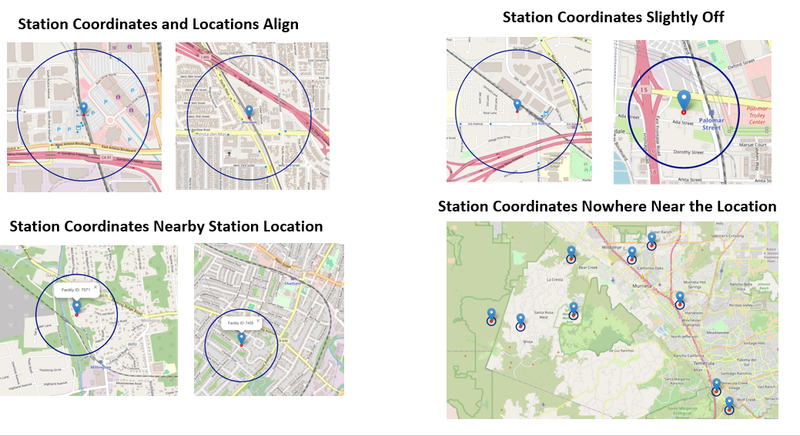

To address these discrepancies, I visually inspected the locations of all station areas plotted against the OpenStreetMap base map, which included the correct location of the station, and excluded stations whose ¼ mile radius did not overlap at all with the correct location. A total of 88 stations were excluded, most of which were associated with commuter rail transit systems. Future project work will perform additional quality control and re-introduce stations into the dataset using correct longitude/latitude coordinates

**8b. Station tabulation methodology.** A second data integrity issue involved tabulating the total number of stations in my dataset. The NTD data assigns a unique four-digit identification number for each station, however this approach might be different from how people who use these stations perceive them. Consider a visitor to the WMATA Silver Spring Metro Station. Once they enter the station, they have access to both the WMATA heavy rail system and the Maryland Area Regional Commuter (MARC) rail system. Many people would consider the station to be a single station since the two platforms are physically and functionally related. However the NTD dataset considers these stations to be two separate stations.

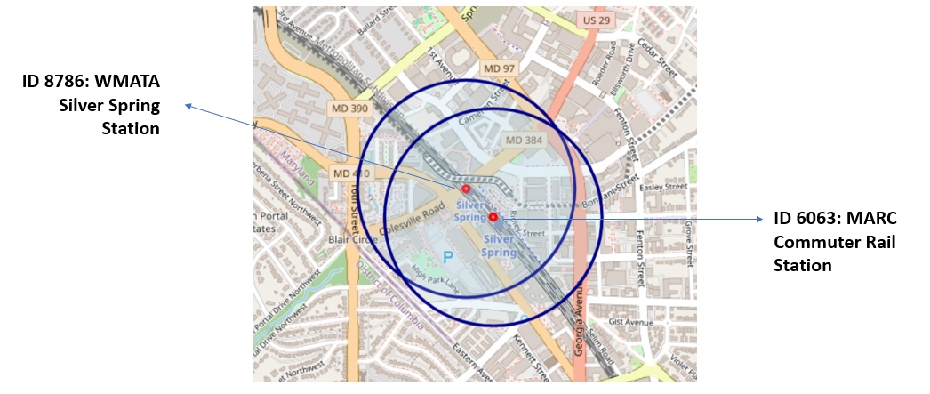

This scenario is common when it comes to multi-modal transit hubs such as New York Penn Station, Union Station in Washington DC, and many others.

Discrepancies between how the NTD dataset counts stations and how people may perceive them also arise in streetcar systems that have platforms on the opposite sides of the street to serve trains that come in one direction and other such as these stops along the Milwaukee Streetcar line (unlike the stations with duplicate lon/lat coordinates described in Section 6a, typically consisting of two platforms in the same facility, I considered these records to be separate stations since they have different coordinates).

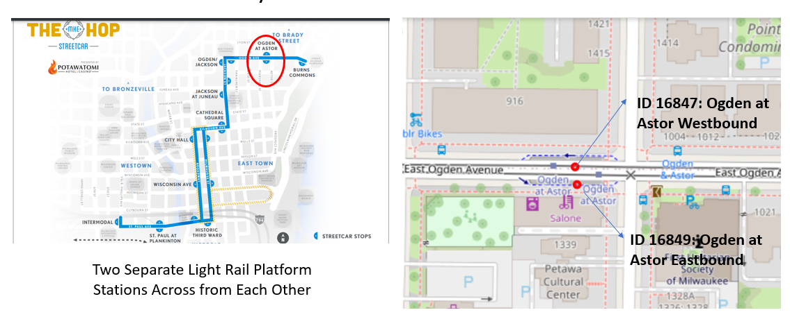

My general approach was to retain the NTD data structure showing stations as separate entities as opposed to combining multiple nearby stations into a single one. However, I did reduce the number of stations in a special category in New York City called “Station Complexes,” where sets of two or more stations are connected with a passageway, inside fare control, and stations serving two or more lines. The image below shows one such station complex:

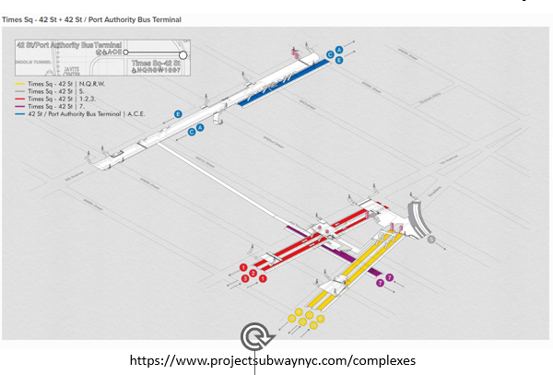

The MTA New York City Transit website identifies 32 such station complexes and the NTD includes separate station IDs and lon/lat coordinates for each one. I kept the first station in a complex listed on the MTA website and excluded the remaining stations. This reduced the total number of New York City Transit stations in my dataset from 472 to 424 stations.

**8c. Station area overlap.**The phenomenon of stations with overlapping ¼ mile radius areas posed additional limitations for data analysis because features within each catchment area, such as the number of buildings, acres of land for various uses, and people residing in the area would be attributed towards multiple stations. It is not uncommon for transit stations in a region’s core to exist relatively close to one another. For example, the image below of WMATA stations in Washington DC shows multple overlapping stations downtown.

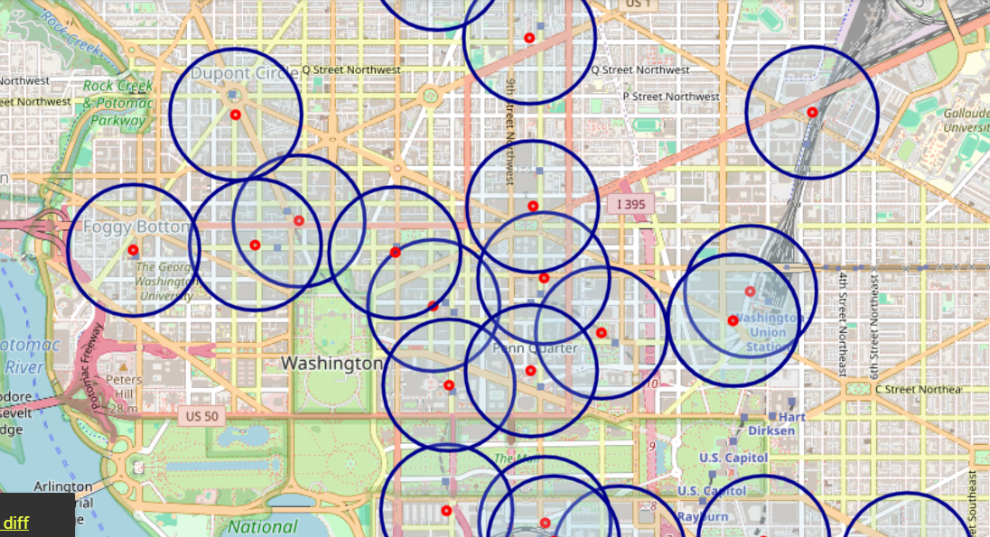

Streetcar systems and bus rapid transit lines often also have stations placed relatively close to one another along a corridor, such as this Bus Rapid Transit line in Richmond, Virginia:

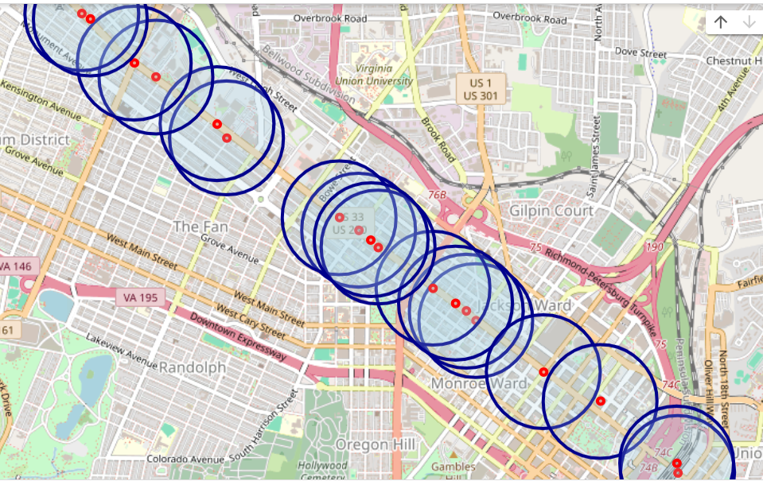

To determine the total number of station areas that overlap with one another, I performed a balltree analysis using a Scikit Learn library application and found that around 2,000 of the 3,900 stations in my dataset are located less than 800 meters from at least one other station, meaning that at least a portion of the station areas overlaps.

Because the number of station areas that overlap and the distance of the overlap varies, there is no obvious way to pro-rate features that are in shared station areas. As a result, it is impossible to sum the total number of people, houses, or other features that reside around multiple overlapping stations without double-counting. However, using descriptive statistics such as comparing means and medians of attributes around stations in one system or another (or in one time period or another) is feasible, as is calculating and comparing proportions, such as the proportion of the nonwhite population that resides within or near a station area.

**8d. Land Cover Overestimates.**  After analyzing the results of my OpenStreetMap land cover and land area queries, I spotted results where the areas attributed to residential and comercial districts, natural features and transportation features exceeded the station area readius as a whole. For example, my query identified 4,811,625 meters of woodlands (shown in dark green in the image below) associated with the Virginia Railway Express Spotsylvania station. The total area of any circle with a radius of 400 meters is approximately 502,654 meters and it appears from looking at the image that woodlands make up around 20-40% of the area within th ¼ radius of the station. It is likely that my script did not adequately identify features extending beyond the boundaries of the circle and “clip” them to only count the area inside the circle.

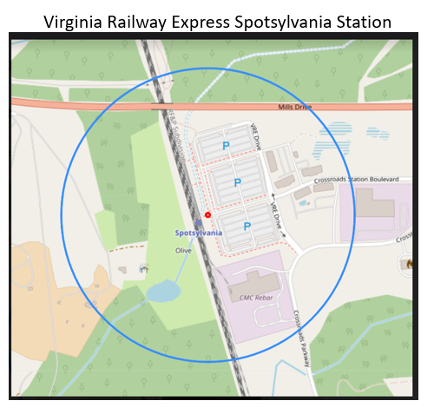

A total of 952 of the 3,900 stations in my dataset (24%). included one or more features with land areas calcluated to be larger than the radius of the circle. In general, I addressed this issue by analyzing the presence or absence of a certain land cover of a (assigning a 1 to presence and 0 to absence) rather than the total land area associated with a feature. The exceptions were building area and parking lot area where I excluded a handful of stations whose square footage of these features exceeded the entire station area.

**8e. Large Census Boundaries.** Data on median home value and rent are available at the Census Block Group level which is the second smallest geography available (only the block geography is smaller). While most census block groups expand beyond the quarter-mile catchment area, some block groups also fall withn the boundaries of a ½ mile or ¾ mile circle from the station. For example, almost all of the land area covered by the block groups surrounding the WMATA Bethesda metro station (shown below left) fall within a ¾ mile radius of the station. While there is no single standard for the distance from a transit station which constitutes “transit oriented” development, most practitioners might perceive land uses and population within ¾ of a mile from a station to be TOD or at least transit adjacent.

However, my dataset includes some stations in less densly populated areas whose block groups cover significantly more land area, extending much further from the station, such as the block groups around the WMATA Spring Hill Station (shown below right). In these instances, many if not most of the housing and population in the block groups would live too far away from the station to have a menaningful physical or functional relationship with the station.

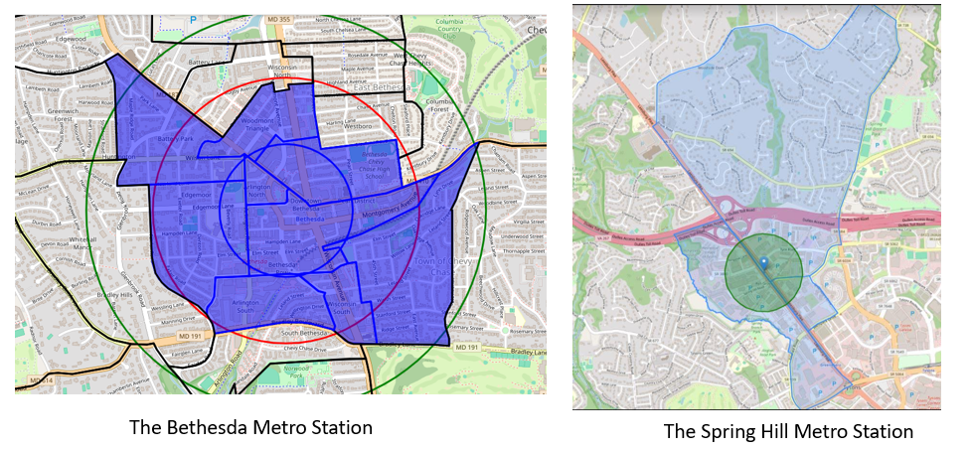

Of the roughly 3,900 stations in my daaset, 930 stations (23%) were surrounded by block groups with total areas of over 4,523,893 meters, which corresponds to the area of a circle with a ¾ mile radius. I excldued these stations from the analysis of home prices and rents.

**8f. Changes in Census boundary areas over time.** My project evaluates changes in land use and land cover and demographics between 2010 and 2020. Although Census block and block group data is available for both the 2010 and 2020 Decennial Census, changes to the Census polygons or other methodologies makes it dofficult to compare change over time. For example, the image below shows census block groups that intersect the transit station catchment area near Arizona State University in Tempe, AZ. If the 2020 Census showed an increase in the population living around this station, would it be because more people moved to the blocks surrounding the station or because the boundaries of the block that includes a portion of the University expanded?

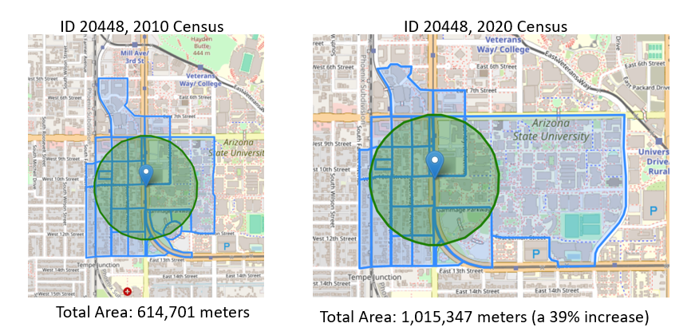

To identify the extent to which census boundary changes occurred between 2020 and 2010, I tallied the total area associated with 2020 and 2010 census blocks intersecting with the catchment area. This comparison can help to distinguish between "signal" and "noise" in data—where "signal" represents actual demographic shifts towards or away from transit stations, and "noise" might be attributed to methodological changes in data collection or area boundary adjustments. Of the 3,900 stations, 900 (23%) had no change in boundary area and the average change was 3% in either direction. A reference table of stations and the land/water area associated with 2010 and 2020 block boundaries is available along with the demographic data for users who would like to explore the potential role of boundary changes in influencing demographic change in greater detail.

**9. Feature Derivation**

Feature derivation is a process used to modify existing data to bring out a more useful form (such as a proportion instead of a total), combine two or more features to create a new feature that provides more insight than any of the individual features alone, and use domain knowledge to create new variables from raw data. For example, I categorized stations by the combination of the mode of service and station type to identify underground heavy rail stations vs. at grade heavy rail stations. Other dervied metrics include the percentage of building footprints relative to station area, average footprint per building, and the proportion of parking areas. I also created a measure of the building-to-parking footprint ratio and a metric that identifies the presence of major road infrastructures like highways and busy roads. Additional metrics include sidewalk coverage and the presence of designated land uses such as retail, commercial, and educational, along with the overall availability of amenities. This process involves trial and error and not all derived features created were used in further analysis. The table below identifies this project’s most relevent derived variables:

|  |  |
| --- | --- |
| **Derived Feature** | **Definition** |
| Mode of Service-Facility Type | Concatenates the "Primary Mode Served" and "Facility Type" of each station |
| Decade a station was built | Aggregating the year a station was built or fully renovated by decade. |
| Data quartiles or quntiles | Grouping data such a transit system's number of stations or counties cities served into 4 or 5 tiers |
| Percentage building footprint | The proportion of station area land occupied by buildings |
| Average footprint per building | Building footprint area divided by number of buildings |
| Percentage parking areas | The proportion of station area land occupied by parking. |
| Building-Parking Ratio | The amount of land occupied by buildings compared to parking |
| Presence of a highway | 1 if land in the station area is identified as a highway and/or a trunk road, 0 otherwise. |
| Presence of a busy road | 1 if land in the station area is identified as a primary road, 0 otherwise. |
| Percentage of sidewalk coverage | The proportion of street segments in a station area that include sidewalks |
| Presence of a retail district | 1 if land in the station area is identified as a retail area, 0 otherwise |
| Presence of a commercial district | 1 if land in the station area is identified as a commerial area, 0 otherwise |
| Presence of an education campus | 1 if land in the station area is identified as an education area, 0 otherwise |
| Total number of amenities by category | The total number of categories where at least one amenity is present |
| Total number of amenities | The total number of amenities across all categories |
| Percentage change over time | Calculating the percentage in a variable over time (typically used with the Census demographic data such as housing, population, and demographic composition |

**10. Feature Creation**

Unlike feature derivation, which involves extracting additional useful information from existing data. Feature creationgenerates new data variables using subject matter expertise, and combines existing features in a way that they produce new insights. This section describes the following features:

**10a. Transit System Categories.** Transit systems in the United States are each shaped by a unique blend of historical timing, economics, politics, social attitudes, climate, geography, and technology. Although no two are exactly alike, it is possible to group systems into meaningful categories based on the time when they were designed and constructed, the mode of transit used, their geographic location, and other factors. These categories may provide insights into the extent to which the history and political economy of transit systems have informed TOD today. I grouped the 69 transit agencies in my dataset into eight categories. Although I invented these categories myself, I was informed by material in The Lost Subways of North America by Jake Berman, a history of transit system development in the 19th and 20th century.

Category 1: Legacy Rail Systems

This category encompasses some of the oldest transit systems, with roots stretching back to the 19th century. Initially operated by private entities and later transitioned to public management, these systems serve the dense, highly populated regions of the Northeast Corridor and Chicago. They are characterized by older facilities and infrastructure that are integral to the daily commute of millions. Examples include subway systems operated by the Massachussetts Bay Transit Authority (MBTA), the Metropolitan Transit Authority New York City Transit (MTA NYCT), the Southeastern Pennsylvania Regional Transporation Authority (SEPTA), and the Chicago Transit Authority (CTA). There are seven systems in this category.

Category 2: Post-War Regional Heavy Rail Systems

Conceived in the 1960s and coming into operation in the 1970s, these systems were developed as a modern alternative to highways, linking suburbs with central cities. Notably, they represent the last major regional subway systems constructed in the United States. There are fixed guideway modes operated by three systems in this category: The Bay Area Rapid Transit (BART), Metropolitan Atlanta Regional Transit Authority (MARTA), and Washingtom Metropolitan Area Transit Authority (WMATA).

Category 3: 20th Century Systems

This category includes a mix of subway and light rail systems that were designed and built in the latter half of the 20th century, ranging from single-line operations to more expansive networks. These systems dot various regions, from the declining populations of "rust belt" cities to the burgeoning metropolises of the West Coast and have experienced various degress of success when it comes to daily use. The Greater Cleveland Regional Transit Authority (GRCTA), the Niagara Fronteir Regional Transit Authority (NFTA) light rail line, the Maryland Transit Authority’s (MTA) light rail system in Baltimore, and the Tri-County Metropolitan Transit District (Tri-Met) in Portland, Oregon. There are ten systems in this category.

Category 4: 'Sun Belt' Systems

Located in the rapidly growing southern cities post-World War II, these systems were added between the 1980s and 2000s and located in the Southeast, Southwest, and southern California. They emerged in regions experiencing large population growth and in an era when urban planning heavily favored highways and low-density suburbs. Examples include fixed guideway modes operated by Miami Dade Transit (MDT), the Dallas Area Rapid Transit (DART), Valley Metro serviing the city of Phoenix, and the Los Angeles Metropolitan County Transit Authority (LACMTA). There are six systems in this category.

Category 5: 21st Century Light Rail Systems

These systems were planned in the 1990s and became operational after 2000 as regional leaders looked to light rail systems as less costly alternative to heavy rail to provide regional rapid transit. These systems often connect cities with their suburbs and are found across diverse regions from the Southeast to the West Coast. Examples include fixed guideway modes operated by the Central Puget Sound Regional Transit Authority (Sound Transit), in Seattle, WA, the Charlotte Area Transit System (CATS) in Charlote, NC and the Denver Regional Transit District (RTD).

Category 6: Modern Streetcar Systems

These systems mainly serve smaller cities in the Southeast and Midwest, focusing on downtown revitalization and providing options for tourists and local circulation. They began operation after 2000 and are tailored to areas without the population density or tax base to support larger regional transit systems. (Note: while some systems in other categories operate a streetcar mode in addition to other fixed guideway services, this category includes cities where streetcar is the only fixed guideway transportation). Examples include the City of Cincinnati streetcar, the City of Milwaukee streetcar, and the Hillsborough Area Transit Authority (HART) streetcar in Tampa, Florida. There are 9 transit systems in this category.

Category 7: Bus Rapid Transit (BRT) Systems

These systems are prevalent in smaller cities and are designed as an economical and flexible alternative to rail. They have been operational since 2000 and seek to offer swift transportation options akin to rail services but with the cost-effectiveness and adaptability of road-based transit. (Similar to modern streetcar systems, this category includes cities where the only fixed guideway mode of transportation is BRT. Examples include systems in Albuquerque, NM, Indianapolis, IN, and Richomond Virginia. There are six transit systems in this category.

Category 8: Commuter Rail Systems

Providing longer-distance, less frequent service, commuter rails connect cities with suburbs and span multiple regions. Often sharing tracks with freight and Amtrak trains, these systems include park-and-ride facilities and have historically served downtown office workers. Post-pandemic, many commuter systems are grappling with greater numbers of people who work from home, fewer commuters, and shifting ridership patterns. Examples include New Jersey Transit (NJT) serving New Jersey and portions of New York and Pennsylvania, the Northeast Illinois Regional Commuter Railroad Association (Metra) serving the Chicago Region, and the Southern County Regional Rail Association (SCRRA) serving Southern California. There are 20 systems in this category.

**10b. Transit Station Proximity.** Transit-Oriented Development (TOD) that is close to multiple stations instad of a single one may have greater value to developers and residents because each station operates as a node in a network. People living in close proximity to more than one nodes may have easier transit access to destinations throughout the network, especially if some of the nodes cross modes or systems. For example, in the image below, a resident of downtown Portland, OR has access to destinations around multiple nearby City of Portland streetcar stops as well as destinations around the Tri-Met regional light rail system. Similarly, land uses in downtown Portland that may attract a large number of people (such as offices, convention centers or stadiums) are wel postiioned to draw people from throughout a region if they are located near multiple stations with multiple modes/systems.

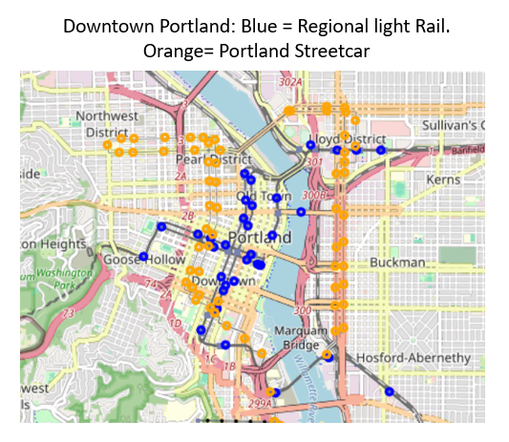

The transit station proximity feature accounts for the spatial relationship between stations, treating each station in my dataset as a “reference station” and counting the number of stations that are within 800 meters in any direction from the reference station. These nearby stations are considered “proximate stations.” The feature also calculates the distance between the reference station and proximate stations, and whether or not any of the proximate stations are different modes of service or operated by different transit sytems from the reference station. The chart below provides a set of reference stations, proximate stations, and metrics for several stations in Washington, DC.

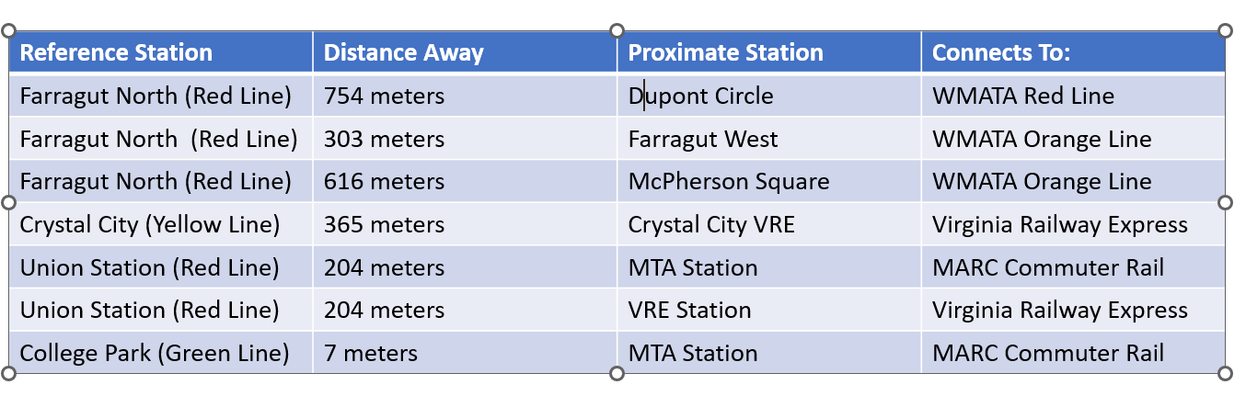

The station proximity feature groups all stations into the four, hierarchical categories shown below.

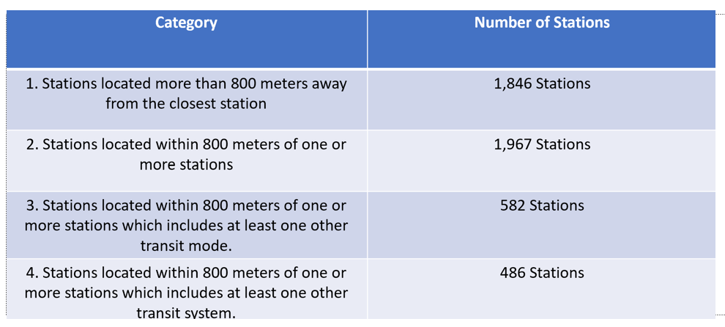

These categories are used in later analysis designed to identify high priority station areas for new development.

**10c. Walkability Score.** The term “walkability” is used frequently in urban planning. While there is no one universallly shared definition, the term usually encompasses concepts of pedestrian safety, convenience, comfort, and access to destinations. For example, U.C. Berkeley city planning professor emeritus Michael Southworth defines walkability as the degree to which the built environment supports and encourages walking by offering pedestrian comfort and safety, connecting people with various destinations within a reasonable time and effort, and providing visually interesting journeys throughout the network (FN) (<https://ascelibrary.org/doi/full/10.1061/%28ASCE%290733-9488%282005%29131%3A4%28246%29>)

Taking these concepts into account, I developed a scoring system to measure and compare walkability around a station area. A total of 30 points can be assigned. If a highway or busy road is present in the neighborhood, it scores 0; otherwise, it is awarded 5 points. The same scoring applies to the absence of rail infrastructure. Furthermore, the number of street segments or intersections contributes to the score, based on percentiles; more intersections indicate better walkability and are scored between 1 to 5. Similarly, the average street length influences the score; shorter streets are considered more walkable and are also scored between 1 to 5. Finally, the percentage of streets equipped with sidewalks is a crucial factor, with more sidewalks translating to a higher score on a scale of 1 to 5. The scoring system and the distribution of transit station neighborhoods by walkability score are shown below:

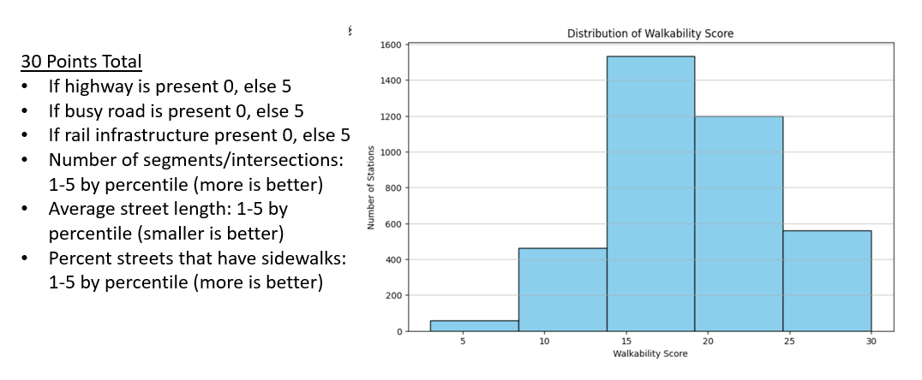

**10d. Transit Oriented Development Score.**  While no two transit station areas are identical, all areas have some shared attributes (such as building density or transportaton network characteristics) that can be used to measure extent to which a station area contains dense, walkable, mixed use build environment. I created a TOD Score to help city planners and decision-makers see how well different areas are doing in terms of development around transit stations, and where there might be room for improvement.

The score uses five factors: building count, building footprint, the walkability score, the presence or absence of designated land uses (such as commercial, retail, or educational districts) and the numberof amenities in the station area. Each factor is converted to the same scale and weighted to comprise 20% of the total score which can range from 0 to 1. The table below presents the distribution of stations by their score, The highest TOD Score obtained is 0.71, indicating that while no area is perfect, there is room for improvement in developing transit-oriented areas. The mean TOD score is 0.256.

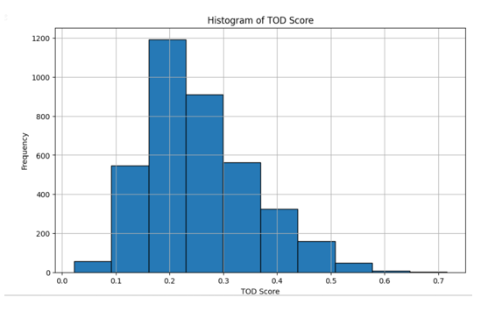

**10e. Transit Oriented Development Potential Score.** This feature is similar to the TOD Score and can range from 0 to 1 except that instead of considering how well-developed areas are right now, it looks at their potential for development in the future. This score uses three features derived from OpenStreetMap data (per Section 9): the percentage of a station land area that is covered by buildings, the percentage of the area covered by parking, and the percentage covered by natural features such as parks, woodlands, or water. As with the TOD score, each factor is normalized. The script assigns importance to each feature with weights. For example, extensive parking might mean there's a lot of space that could be developed in the future, so it's given a positive weight. On the other hand, a large building footprint might mean there's less space available to develop, and lots of natural features could limit where new development can go — so these are given negative weights. The formula gives parking a postive 50% weight and building footprint cover and natural feature cover negaitve 25% weights respectively.

My method addresses the issue of land cover overestimates (Section 8d) by excluding stations with building, parking lots, and natural feature areas that are greater than the station area as a whole. It computes a potential score for each area and if any scores are negative (which could happen with the way weights are assigned), it adjusts them to ensure they are all positive. The table below presents the distribution of stations by their TOD potential score. Because some stations with erroneous land areas needed to be excluded, my dataset with potential DOT scores includes 3,323 stations instead of the 3,803 stations in the complete dataset. Scores range from 0 to 0.83 with a mean of 0.32.

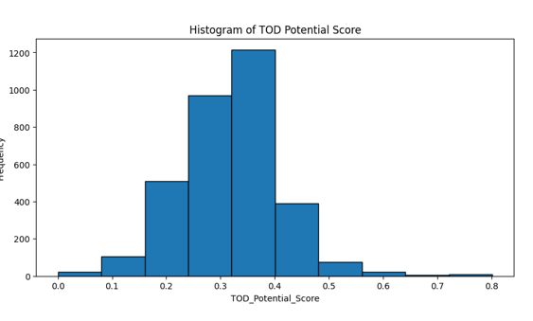

**11. Machine Learning Applications**

Machine learning is a branch of artificial intelligence that enables systems to learn from data, identify patterns, and make decisions with minimal human intervention (FN). The purpose of machine learning is to develop algorithms that can process large amounts of data more efficiently and make predictions or decisions based on that data, improving over time as they receive more information.

One branch of machine learning, called supervised learning provides an algorithm with both the input data (such as a station area’s land use and transportation features) and the corresponding correct outputs (such as a station area’s TOD score). The goal is for the model to learn the relationship between the input and output, so it can predict the output for new, unseen data (such as transit stations in the planning stages of development and not yet included in the NTD dataset).

A second branch, called unsupervised learning, provides an alogirthm with input data without any corresponding output labels. The system tries to learn the underlying structure from the data itself. Unsupervised learning is useful in scenarios where you don’t know what the results should look like or when you want to explore the data to find patterns that are not immediately obvious.

My project employed both unsupervised and supervised learning, as described below.

**11a. Clustering with K-Means.**

Clustering is an unsupervised machine learning method that sorts through complex data and groups similar items together based on shared charactristics. When applied to my dataset, this method can help divide transit station areas into meaningful market segments, reveal underlying structures of built environments, and help guide decision making and policy development, in particular to match different community development strategies to different areas.

My approach chose five station area features that inform TOD: the number of buildings, percentage of the station area covered by buildings, the station area’s walkability score, total number amenities, and presence or absence of designated land uses (i.e. retail districts, commercial districts and/or educational campuses). I adjusted the values so that each feature contributed equally to the analysis.

I then applied a K-means clustering algorithm to this data. K-means is a popular method used in data analysis to automatically group similar things together. I decided to break my dataset into clusters ranging from 2 to 10 segments and ran the K-means algorithm on each variation (on two clusters, then on three clusters, then on four, etc). The algorithm starts by randomly picking the pre-selected number of points in the data as the initial centers of the groups (for example, the scenario with two clusters picks two starting points at random). Each piece of data is then assigned to the nearest group center where "nearest" means that the data point is more similar to the center of this group than to the center of any other group. Similarity is measured by distance: the closer two points are, the more similar they are considered to be.

Once all data points are assigned to groups, the algorithm recalculates the center of each group. It does this by finding the average of all the points in each group—the "mean" in K-means. This new center is more representative of the group's members. These steps are repeated until the centers stop changing significantly.

In order to determine which number of clusters (between 2 and 10) was most meaningful, I calculated the inertia of the different iterations. Inertia is a measure of how internally coherent the clusters are (in other words, how close the data points in each cluster are to each other). As the number of clusters increases, inertia decreases. The "elbow" is the point where the rate of decrease sharply changes, suggesting a good balance between the number of clusters and the tightness of the clusters.

I also calculated a silhouette score which is a measure of how similar an object is to its own cluster compared to other clusters. A high silhouette score indicates that objects are well matched to their own cluster and poorly matched to neighboring clusters. The inertia and silhouette scores and elbow method graph are shown below.

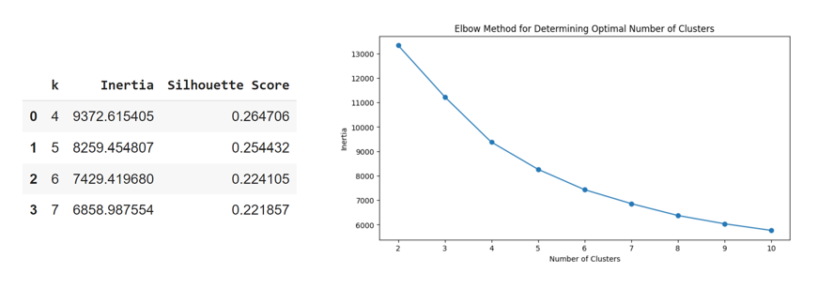

I selected six clusters as the optimal number of transit station area groups. This results in station area characteristics that are relatively coherent with one another and distinct from station areas in other clusters. (In addition, providing more than six clusters would make the task of describing different TOD segmnts overly complicated). Summary statistics of the six clusters are shown below:

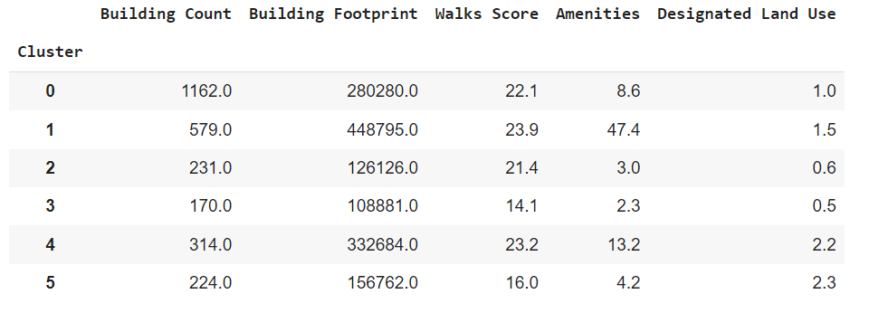

After examining the combination and implication of the feature averages in each cluster I assigned a name to each cluster that reflect’s its overall mix of density, transportation features, amenities, and designated districts. The clusters and names are shown below.

|  |  |
| --- | --- |
| **Cluster Number** | **Cluster Name** |
| 0 | High Density Residential |
| 1 | Commercial Hub |
| 2 | Emerging Mixed Use |
| 3 | Sparse Suburban |
| 4 | Mixed Use Urban |
| 5 | Low Density Suburban |

This paper’s Results section (Section 12) will describe these clusters and their implications in greater detail.

In order to visualize the six clusters I ran a script that reduces the complexity of the data down to two main features that capture the essence of the data. This is done using Princial Component Analysis, a statistical technique that finds the most significant patterns in the data. The two main features from PCA are then put into a new table. This table also includes information on which cluster each data point belongs to, essentially grouping similar points together.

To make the clusters easy to distinguish in the plot, my script assigns a unique color to each, like blue for high-density residential areas or orange for commercial hubs). The script then creates a scatter plot. This plot displays the data points in a two-dimensional space defined by the principal components. Each point is colored according to its cluster, making it easy to see the grouping. The resulting plot, with cluster names I assigned, is shown below.

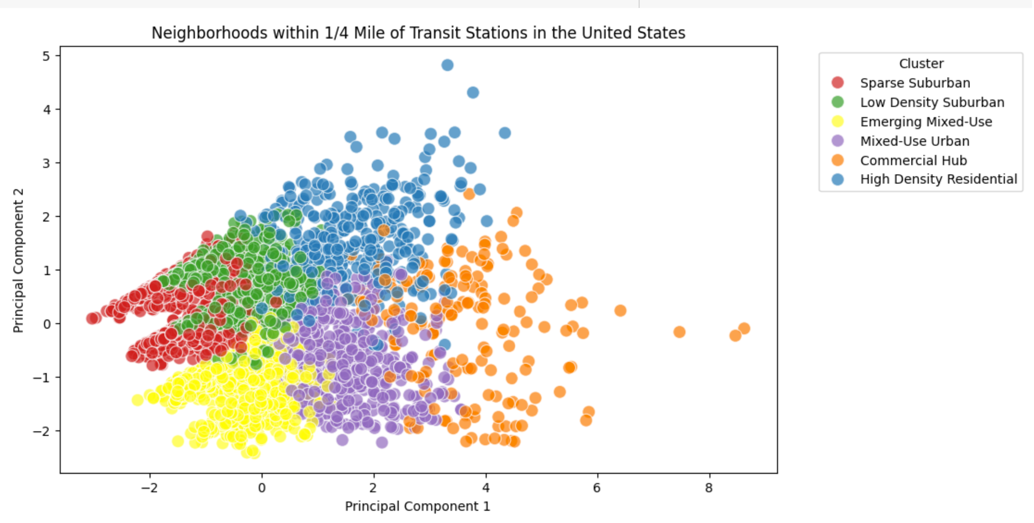

**11b. Linear Regression with Forward Propogation**

This project’s second and third machine learning applications both deploy linear regression, a form of supervised learning. Linear regression is a statistical method used to model the relationship between a dependent variable and one or more independent variables by fitting a linear equation to observed data. (FN)It can help predict outcomes, show how changes in one variables can effect othr variables and can identify which independent variables have the most significant impact on the outcome.

The first regression approach aims to understand how various characteristics of transit systems (the independent variables) influence a station’sTOD score (the outcome or dependent variable). This exercise could be useful for officials who are planning new fixed guideway lines and who are contemplating different types of transit modal alternatives (such as light rail or bus rapid transit) and various types of station configurations (such as elevated stations or at-grade stations). To what extent will a system’s location, design, and infrastructure lead to more or less dense, walkable, and mixed use communities surrounding he stations?

To anser this question I used a dataset comprising 3,803 station areas and features such as the mode of transit (e.g., heavy rail, light rail, BRT), whether stations are above or below ground, the type of transit system (e.g., legacy rail, sun belt systems, 21st Century Light Rail), the decade a station was built, and the extent of the transit network across cities and counties. Some of my data like the decade the area was built or the type of transit mode, are categorical (i.e., represented as categories rather than numbers). The code transforms these categories into a format suitable for analysis (a process known as "one-hot encoding"), which essentially turns categories into a series of 0s and 1s. This makes it easier for the statistical model to understand and use this information.

The table below show’s the model’s independent variables:

|  |  |
| --- | --- |
| **Feature** | **Definition** |
| Primary Mode Served | The transit mode served by the station (i.e heavy rail, light rail, commuter rail, etc) |
| Facility Type | The station's facility type (above ground, below ground, at grade, etc) |
| Mode_Type | The combination of primary mode served and facility type (i.e elevated subway station) |
| System | The transit system category the station is in (i.e. legacy rail, sunbelt systems, etc) |
| Decade Built | The decade the station was built |
| No. Stations | The number of stations in the transit system's network |
| No. Cities | The number of cities serveed by the transit system |
| No. Counties | The number of counties served by the transit system |

The method employed Forward Propagation, where features are incrementally tested and added to the model based on their contribution to improving the model's performance. This process continues until adding more features no longer significantly enhances the model, using a predetermined improvement criterion**.** In order to avoid multicolinearity (a situation where two or more independent variables are highly correlated, which can make it diifficult to determine the effect of each independent variable on the dependent variable) I used domain knowledge to pick combinations of independent variables with little overlap. For example, the model uses the transit mode and decade built as features but does not use the primary mode and the System category because several system categories (like 21st Century Light Rail) and Commuter Rail Systems also include the transit mode.

My code uses a "Random Forest" model, which is a type of sophisticated tool that can predict the TOD Score based on the features provided. This model is particularly good at handling complex relationships within data and providing accurate predictions. The data is then split into two parts: one part is used to teach the model (training set), and the other is used to test how well the model has learned (testing set).

The model is then trained with the training data, meaning it tries to learn the best way to predict the TOD Score from the features provided. After training, the model uses the testing data to make predictions. This step checks how well the model can apply what it learned to new, unseen data.

Finally, the code evaluates how accurate the predictions were using two metrics: the Mean Squared Error (MSE) and R-squared (R²). MSE measures the average error in the predictions (lower is better), and R² shows how well the predicted values match the actual values (a value closer to 1 means a better fit).

The “Results” Section of this paper will describe the outcomes and implications of this model.

**11c. Linear Regresion with Recursive Feature Elimination**

This project’s second linear regression model investigates the impact of transit system characteristics, TOD features, and demographic variables such as race and ethnicity on residential property values and rent prices near transit stations. This analysis might help planners, real estate developers, and others better understand how newly construted transit stations might influence home values and rents in the surrounding neighborhoods, as well as which factors play the most significant role in influencing home values and rents today.

The study uses data from 2,906 stations, focusing on median home values and rents in 2020. (I excluded roughly 1,000 stations whose census block group area exceeded the area of a circle with ¾ mile radius as these stations have homes and apartments that may not be close enough to a station to be considered “transit oriented”).

The table below documents the model’s independent variables:

|  |  |
| --- | --- |
| **Feature** | **Definition** |
| %_2020_White | The percentage of population around a station area that is white |
| %_2020_Black | The percentage of population around a station area that is Black |
| %_2020_Hispanic_or_Latino | The percentage of population around a station area that is Hispanic or Latino |
| %_2020_Asian | The percentage of population around a station area that is Asian |
| %_Change_White | The 2010-2020 change in the percentage of the white population living near the station. |
| %_Change_Black | The 2010-2020 change in the percentage of the Black population living near the station. |
| %_Change_Hispanic_or_Latino | The 2010-2020 change in the percentage of the Hispanic or Latino population living near the station. |
| %_Change_Asian | The 2010-2020 change in the percentage of the Asian population living near the station. |
| Building Count | The number of buildings in the station area |
| Building Footprint | The percent of station area land that is buildings |
| Presence of Highway | Whether or not a highway is present in the station area |
| % Natural Features | The percentage of the station area land that is natural features |
| Walk Score | The station area's walkability score |
| Amenities | The number of amenities in the station area |
| Designated Land Uses | Whether or not a station area included a designated land use (commercial, retail, educational) |
| Cluster Name | The cluster associated with the station area (i.e. sparse suburban, mixed-use urban, etc) |
| Primary Mode Served | The transit mode served by the station (i.e heavy rail, light rail, commuter rail, etc) |
| Facility Type | The station's facility type (above ground, below ground, at grade, etc) |
| Mode_Type | The combination of primary mode served and facility type (i.e elevated subway station) |
| System | The transit system category the station is in (i.e. legacy rail, sunbelt systems, etc) |
| Decade Built | The decade the station was built |
| Station Proximity | The station's proximity category (i.e. not near a station, within 800 meters of one or more station, etc |

After I applied one-hot encoding to convert categorical variables to numbers, the dataset included 83 features.

To winnow down the number of independent variables and identify the most influential ones, I deployed Recursive Feature Elimination (RFE) with a random forest model, which systematically removes the least significant features to identify the most influential ones. This method iterates through the features, refining the model by focusing on those that most effectively predict housing costs, thereby optimizing the feature set for accuracy in forecasting home values and rents. Similar to the first model, my code splits the data into a training and test set, training the model on a portion of the data, making predictions using the test data, and calculating R-squared and MSE performance measures. The “Results” Section of this paper will describe the outcomes and implications of this model.

**12. Results: Insights from Feature Creation, Data Analysis and Machine Learning**

**12a. Two variables-building count and building footprint-can help planners match development strategies to an area’s existing urban form.**

Urban form refers to the physical characteristics that define the built environment of a city or urban area. These characteristics include the layout of streets, the arrangement and density of buildings, the distribution of public spaces, and the overall spatial patterns that make up the urban landscape **(FN).** This project’s data on building count (the number of buildings within the ¼ mile catchment area) and building footprint (the total amount of land area occupied by buildings) can be especially useful towards understanding urban form and comparing/contrasting the morphology of one station area with another.

The image below on the left is a bivariate analysis of the transit stations in the data set with building count plotted on the x axis, building footprint in the y xaxis, and the medians of both variables displayed in the dotted lines, which divide the plot into four quadrants, labeled by the image on the right.

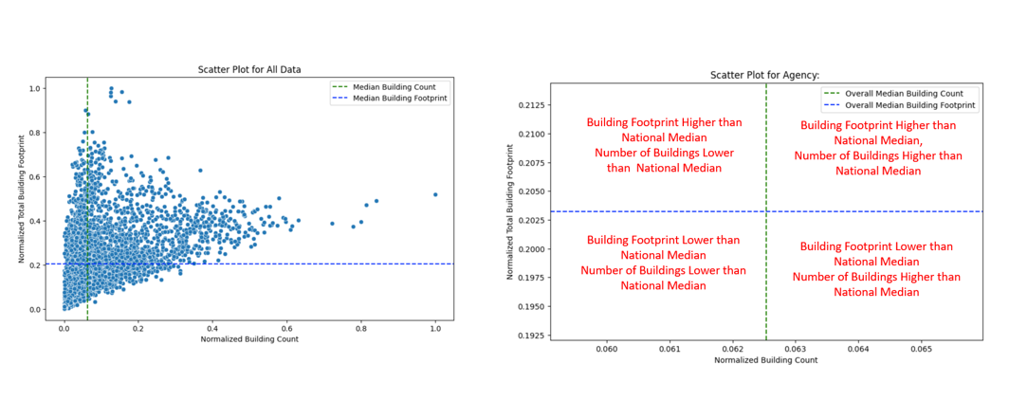

Areas with relatively few buildings that take up a relatively large amount of land are typical of downtown areas, whereas areas that have both many buildings that occupy a large amount of land can be found in dense residential neighborhoods. Areas with many buildings that occupy relatively small amounts of land are typically found in suburban areas with houses surrounded by yards, whereas areas with few buildings that take up a relatively small amount of land are sparsely developed and other features, such as surface parking or natural features may predominate. The chart below summarizes these characteristics and provides an example of each from the data set.

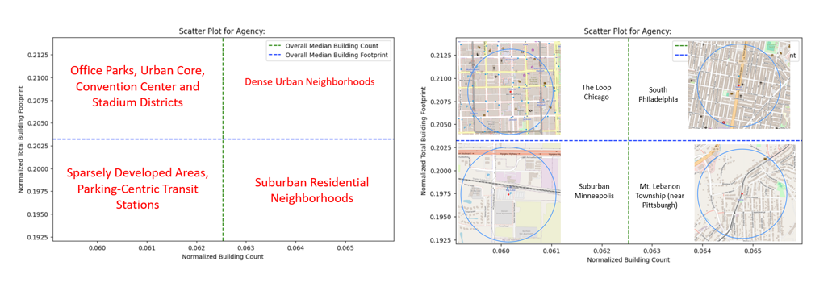

Viewing transit station areas through the lens of the building count-building footprint combination may be useful for planners who want to group similar station areas together and design different interventions for different neighborhoods. The chart below summarizes different development strategies that may be most appropriate for each quadrant.

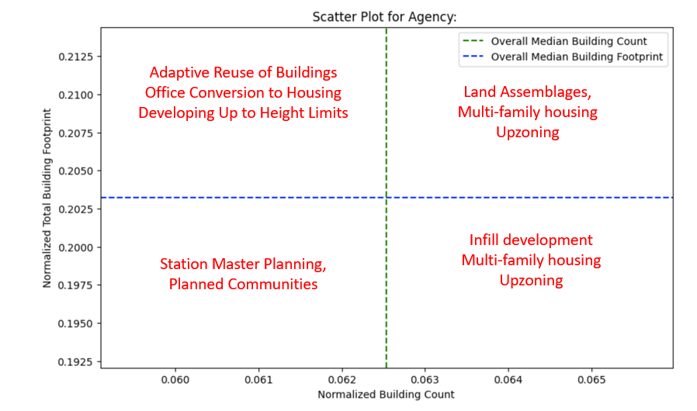

**12b. The densest station areas are around older, heavy rail stations--and streetcar systems**

Urban density can be measured in various ways, from population density to floor area ratio (a building’s total floor area to the size of the piece of land upon which it is built) to the ratio of buildings to green space. This project uses a relatively simple measure of building density which is the percentage of land area around stations that consists of buildings. This measure provides information on how “built out” an area is and, conversely, how much room might be available for new development.

In general, transit stations served by heavy rail, underground stations, and stations built prior to the Second World War are surrounded by the most dense areas. Many of these stations are found in some of America’s most populous cities such as New York, Chicago, Philadelphia, and Boston.

In addition areas around modern streetcar systems have high building density compared to other modes of transportation. For example, the average building footprint percentage around Cincinatti streetcar stations is 70% and the average percentage around City of Milwaukeestreetcar stations is 67% compared to 37% for all stations. Modern streetcar systems serve short-distance travelers in urban cores and have been integrated into existing central business and tourist areas that were already relatively dense. At the same time, some streetcar systems have are gained a reputation for spurring surrounding economic development so some of the building density may have been induced by the system.

In contrast, hybrid rail (a mix of light rail and commuter rail) and commuter rail stations are surrounded by areas with the lowest building density. This likely reflects commuter rail’s traditional role as a feeder system from the suburbs to the cities and the tendancy for many commuter rail stations and parking lots to be build adjacent to one another to allow suburbanites to drive to a rail station and take the train downtown. The tables below rank average building density by various transit system features.

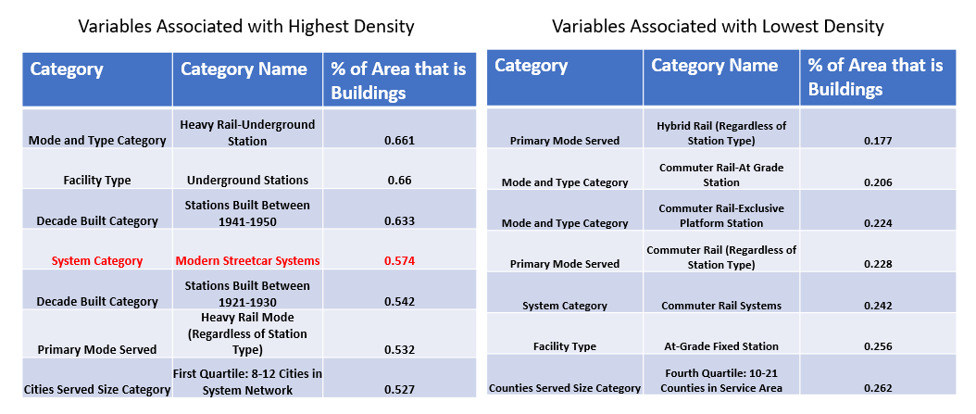

**12c. Almost all stations have nearby surface parking--and commuter lots may be prime candidates for development**

The United States has a lot of parking and the sheer amount of spaces shapes the urban landscape in significant ways. Henry Graber, in his work "Paved Paradise: How Parking Explains the World” writes: “I’ve come to the conclusion that parking is the primary determinant of the way the place you live looks, feels and functions.” (FN). According to Graber, thre are three parking spaces for every car in the United States, accounting for about 5 percent of the land in the continental U.S and a third of the land in mny U.S. Citis are dedicated to parking (FN).

When it comes to transit station areas, the average amount of parking within ¼ mile of a transit station is 67,303 meters which is the equivalent to 12.5 football fields. The table below provides examples of transit stations with various amounts of parking nearby.

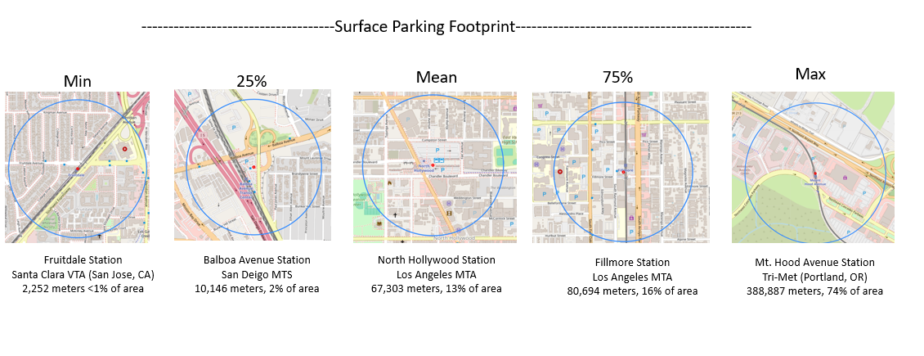

Although the amount of nearby parking varies from station to station, some stations include vary large amounts of land area devoted to parking compared to the amount of land area devoted to buildings. There are 430 stations (11%) where the ratio of parking space to building coverage is greater than 1. Many of these stations are located at the terminus of fixed guideway lines and were designed to be collectors for people living further away to drive to a station and take the train for the rest of their journey to work. The figure below provides examples from the WMATA system. 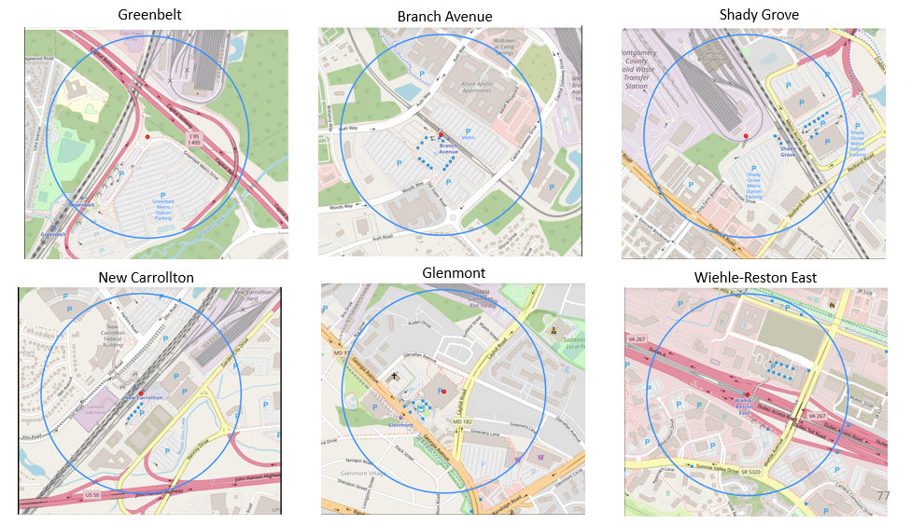

These lots may no longer be consistently full as more people who once commuted four or five days a week now work from home more frequently. Instead, large commuter lots near transit offer an opportunity to convert underused spaces into housing or commercial development and possibly provide a revenue stream to the landowners.

**12d. Almost all station areas have some nearby natural features, likely putting some land off limits to development.**

While surface parking lots and surface garages may provide opportunities for development near transit, other land features pose constraints. These include natural features such as water and woodlands or areas build by people, such as city parks, recreation areas, and cemetaries, that are currently protected from other uses and/or would generate significant opposition if encroached upon. (For simplicity’s sake, this analysis groups both natural and man-made categories under the title of “natural features”) As the table below indicates, a large proportion of transit station areas have at least some land devoted towards one or more natural features, with the greatest share of land cover devoted to parks.

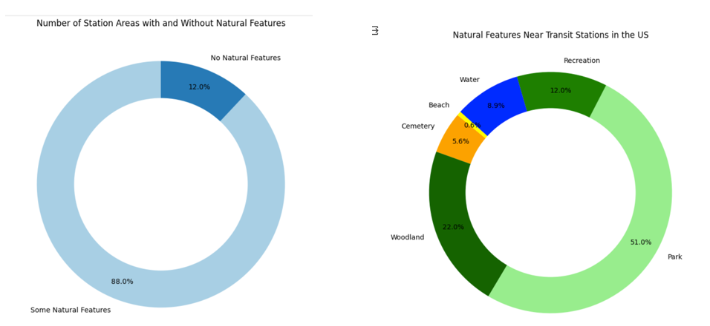

The table below provides examples of natural features located near transit stations:

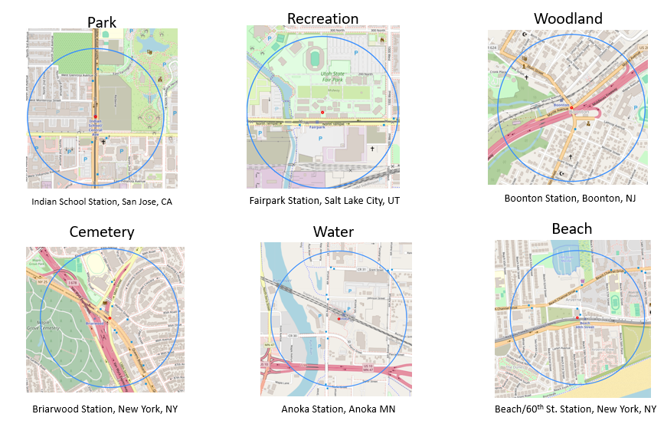

These features may provide amenities and improve the quality of life for people living nearby. Later on, this analysis will investigate the extent to which natural features influence home values and rents and whether there is a meaningful relationship between the demographics of station areas and the amount of natural features.

**12e. About 1/3rd of stations are located near a highway, which may impede access to transit.**

America’s 48,000 mile interstate highway system, devleoped in the mid-20th century, along with a network of state and local highways, significantly impacted cities across the United States and continues to effect urban form and walkability today. Highways reduced travel times, lowered costs for transporting goods, and boosted mobility. At the same time, construction of interstate highways often involved demolishing neighborhoods, particularly in poorer or predominantly minority communities, leading to displacement, community disruption and areas divided by highways.

As the left hand chart below indicates, approximately 1/3rd of transit station areas include a highway (defined as the presence of a highway or trunk road that leads to or from a highway). In some cases, this confluence is due to highways constructed in urban neighborhoods that were already being served by transit. In other cases, transit routes and stations were deliberately planned adjacent to highways because the roadway right of way provided space for rail lines and stations.

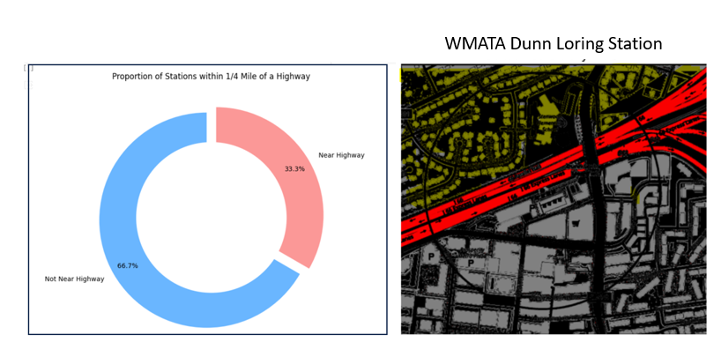

Interstate highways pose several challenges to Transit Oriented Development. They occupy land that might otherwise be put to use for housing, retail, commercial, or other uses. The traffic that uses them can cause harm including air and noise pollution. They are often aesthetically unappealing. Highways also may pose challenges for people who want easy access to a transit staiton and surroundng land uses. Consider the Dunn Loring Station (above image, right) constructed along Intersate 66 (the red band in the image). People living in the residential community (in yellow) live only a few hundred yards away from the station (shown in gray south of the highway). While a foottbridge spanning the eastbound lanes provides access to the station and nearby development, other destinations are less accessible. Acoording to Google maps, it would take 20 minutes for a person traveling from one of the residential strets directly adjacent to the highway to the Harris Teater supermarket on the south side. Faced with the prospect of a circuitous journey, some residents might choose to make a five minute trip by car,

**12f. Over half of stations are located on or near one or more busy road, raising potential safety challenges.**

While highways pose challenges for non-motorist accessibility to destinations, busy roads pose greater danger for vulnerable road user (i.e. pedestrian and bicyclist) and these roads are often found near transit stations. (For the purpose of this analysis, a “busy road” is one that is tagged in OpenStreetMap as a “highway-primary road” and typically shaded in orange).

Many arterial roads are thoroughfares designed to deliver relatively large volumes of traffic at higher speeds compared to local streets. They typically feature multiple lanes and prioritize the smooth flow of car traffic. They connect commercial areas around transit stations to surrounding neighborhoods and help bring customers and employees to areas around transit, but they can also pose safety hazards. The higher speeds on arterial roads can be deadly for pedestrians and cyclists, as higher vehicle speeds increase both the likelihood of crashes and the severity of injuries in accidents. Arterial roads often have fewer safe crossing points and longer crossing distances, making it difficult and risky for pedestrians and cyclists to navigate. The design of these roads can create barriers that split communities and limit safe access to necessary services and amenities.

Per the table shown below, a mojority of transit station areas in the United States have at least one busy road nearby, and some include multple arterial roads close to the station and surrounding development. For example, the WMATA Wheaton Station is adjacent to three arterial roads: Georgia Avenue, University Boulevard, and Viers Mill Road.

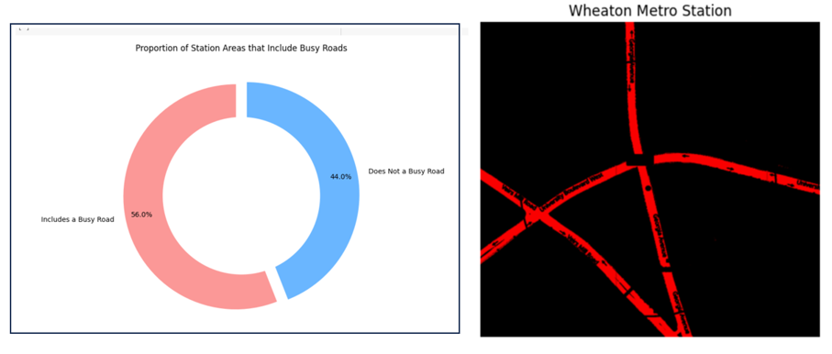

Data about the presence of primary roads near transit stations can help planners better understand existing conditions and plan for ways to mitigate safety risks, such as traffic calming measures, improved crosswalks and intersections, dedicated signage, and other interventions.

**12g. Some Stations Are Surrounded by Walkable Street Grids—But There is Significant Variation**

In contrast to areas bounded by highways and primary roads, neighborhoods with many short streets and intersections and ample sidewalk coverage are inviting. More intersections mean a dense street network, offering pedestrians more route choices and easy access to destinations. Shorter blocks tend to slow car traffic, and sidewalks can separate pedestrians from cars and create a sense of safety.

The table below provides summary statistics for the number of interections, number of street segments, average street segment length, and percent of street segments that also contain a footway (i.e. sidewalk). It is difficult to know whether areas around transit have shorter blocks and greater sidewalk coverage than elsewhere absent data on areas not served by transit or for a city or county as a whole. Average block length around stations is relatively short with a mean of 65 meters and a standard deviation of 31 meters (by comparison a north-south Manhattan City block is 80 meters). An area’s sidewalk coverage also varies significantly with a mean of 56% sidewalk coverage and a standard deviation of 32%.

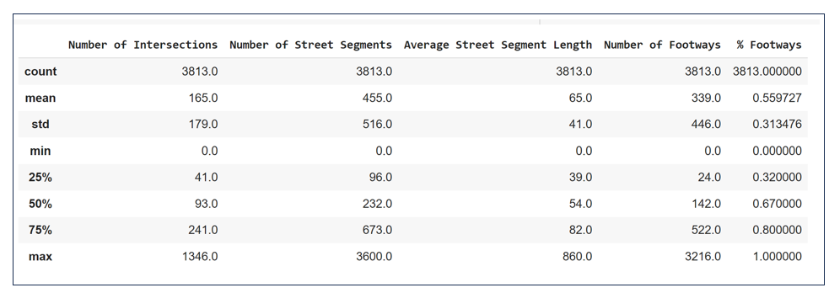

The table below provides a visual explanation of the variation in block length, number of intersections and average street segmenth length around selected WMATA statons, including some of the most inviting pedestrian neighborhoods and ones that pedestrians may find less hospitable.

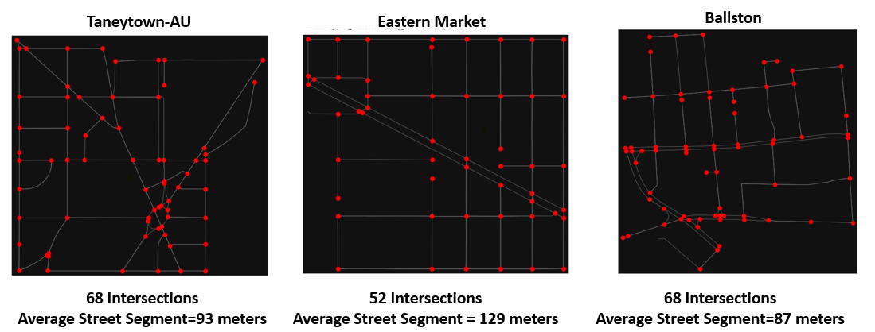

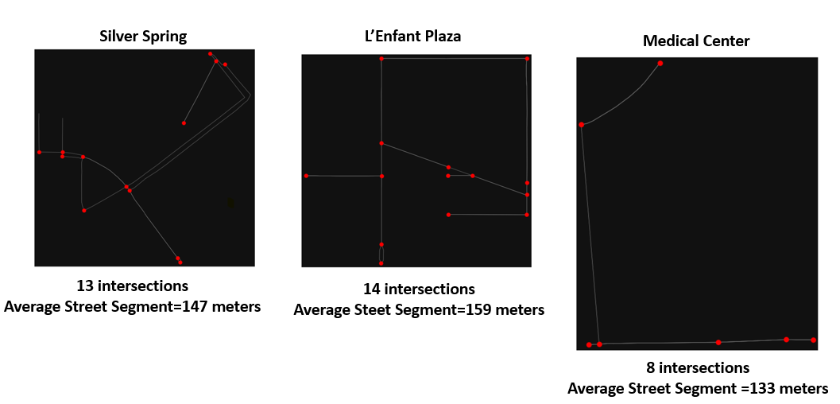

**12h. One in five transit stations are located in “amenity deserts” while 1% are in neighborhoods teeming with amenities.**

In recent years, many urban planners have advocated for the “15 Minute City”: the idea that residents should be able to meet most of their daily needs within a short, convenient walk or bicycle ride from their homes. This includes access to work, education, shopping, health care, culture, and leisure**.** Fifteen minute cities reduce the need to use cars for short trips and may decrease traffic congestion, lower pollution levels, and reduce overall carbon emissions. The concept also encourages more active lifestyles, with increased walking and cycling, and provides more time for leisure and family by reducing commuting times.

However, this project’s dataset reveals relatively few transit station areas that would qualify as “fifteen minute cities.”

As shown in the donut chart below, the share of total amenities are relatively evenly distrbuted across categories with no category except for places of worship exceeding ten percent of the total. However, when it comes to the distribution of amenities across stations, the results are uneven. Eight hundred areas, or about one in five, lack amenities in any of the sixteen categories. Seven hundred and twelve stations have an amenity in one category and 573 stations have an amenity in two categories. As the number of amenity categories increases the number of stations that have amenities in multiple categories decreases. Two stations, the Spring Street subway station in Manhattan and the 10th and Adler Streetcar Station in Portland, have amenities in 14 categories within ¼ mile of the station.

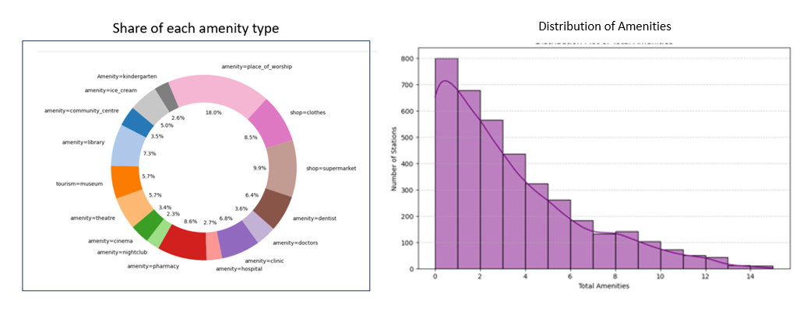

As discussed previously (Section 6d) The dataset includes binary data on amenities by category (assigning a 1 if one or more amenitiy in each category is present and 0 if not) along with the total number of amenities in each category. This second layer may help identify stations that are in particularly amenity rich neighborhoods such as theater, fashion, or nightclub districts. The chart below identifies a distribution with a long right hand tail. The mean number of amenities (in stations with one or more amenities) is nine. Fifty-seven stations have 50 or more amenities and four stations (all of which are in New York City) have over 100 amenities. While residents of a handful of station likely have all of their daily needs within walking distance. The notion of the fifteen minute city has not come to fruition for residents of most station areas.

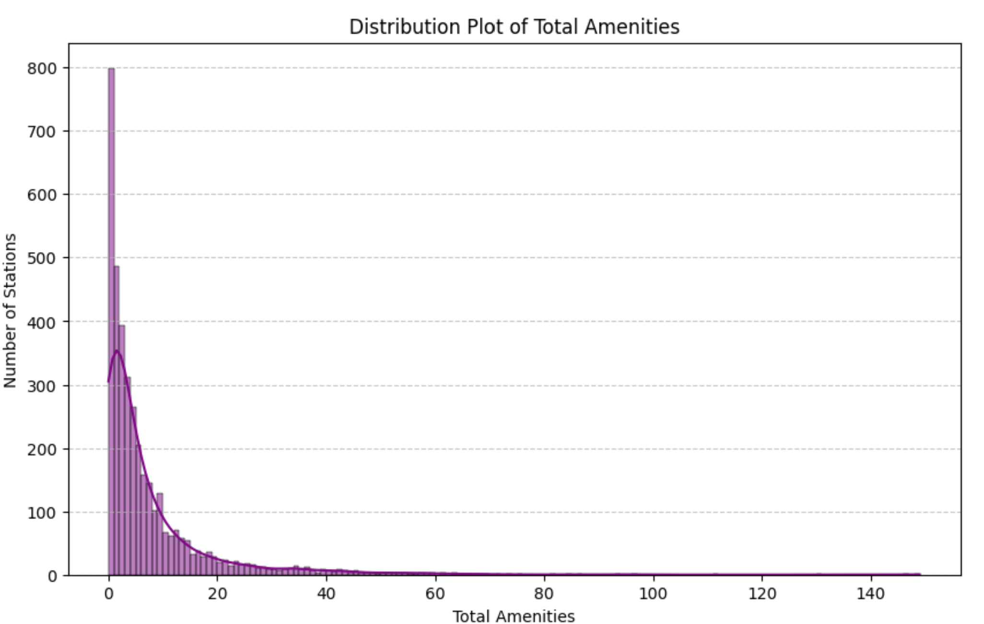

**12i. Clustering can help practioners match community development strategies to existing conditions.**

So far, this paper has presented insights on the building blocks of TOD: urban form, land cover transportation networks, and commercial and retail diversity. The clustering analysis presented earlier (Section 11a) can help us better understand the interrelationship between these factors. This section summarizes the clusters shown earlier and discusses how different development strategies may lend themselves to different segments.



Sparse Suburban

This cluster consists of 964 stations. The average building count is around 170, indicating these are less densely populated suburban or exurban areas. The total building footprint is relatively small at about 108,881 square meters, and the walkability score is low at 14.11, suggesting that these areas are not very conducive to walking. Amenities are scarce, averaging around 2.29, and designated land use (i.e. presence of a retail, commercial, or education district) is also low at 0.54, pointing to limited designated uses. The TOD strategy for this cluster focuses on prioritizing foundational changes to improve the urban layout, creating centers of activity, and enhancing accessibility and land use diversity.

Low Density Suburban

Cluster 2 comprises 889 stations with characteristics typical of low-density suburban areas. The building count is relatively low at around 231, and the total building footprint is approximately 126,126 square meters. The walkability score of 21.38 indicates reasonable walkability. However, amenities are few, averaging 3.02, reflecting fewer services and facilities. Designated land use is similarly low at 0.57, mostly non-designated or single-use areas. The TOD strategy here aims to transition from a car-centric layout to a more pedestrian-friendly setup by increasing both the density and the diversity of land uses.

Emerging Mixed-Use

This cluster, with 838 stations, features a moderate building count of around 224, less than in cluster 2, and a medium building footprint of approximately 156,762 square meters. The walk score of 15.97 suggests these are emerging urban or suburban areas with moderate walkability. Amenities are limited, with an average of 4.16, while designated land use is the highest among all clusters at 2.25, suggesting these areas have multiple designated uses and are potentially in the process of development or transition. The TOD strategy here focuses on making these areas more walkable and attracting more amenities.

Mixed-Use Urban

Cluster 4 includes 556 stations, typified by moderate building counts of around 314 and a large building footprint of approximately 332,684 square meters, indicating significant urban development. The walk score is high at 23.24, suggesting good pedestrian infrastructure in urban areas. Amenities are above average at 13.23, indicative of a variety of services and amenities. Designated land use is also higher at 2.17, typical of mixed-use urban areas. The TOD strategy for this cluster focuses on building upon existing infrastructure to attract more amenities and fine-tuning walkability.

High Density Residential

This cluster includes 392 stations with a high building count of approximately 1162, indicating densely built areas. The building footprint supports this with a large total of approximately 280,280 square meters. The walk score is high at 22.13, and amenities are moderately available with an average of 8.56, suggesting residential areas with some services. Designated land use is close to 1, indicating most areas are designated for a single specific use, likely residential. The TOD strategy focuses on integrating commercial amenities into these residential areas to transform them into more vibrant mixed-use environments.

Commercial Hub

The smallest cluster, with 174 stations, features a moderate building count of around 579 and a very large building footprint of approximately 448,795 square meters, suggesting larger commercial buildings. The walk score is very high at 23.87, and amenities are very abundant, averaging 47.44, indicative of commercial or mixed-use areas with many services. The designated land use average is 1.5, suggesting a mix of uses, possibly areas transitioning between commercial, retail, and educational uses. The TOD strategy focuses on balancing the commercial dominance with residential spaces to create a more integrated urban environment.

**12j. Successful examples of TOD can be found around the country--but most of the stations with the highest TOD scores are located in just six cities.**

As discissed in Section 10d,each station in the dataset was assigned a TOD score, potentially ranging from 0 to 1, based on the combination of number of buildings, building footprint, walkability score, amenities, and designated land uses in the area. The average TOD score across all 3,800 stations is 0.255. Although station areas with high TOD scores can be found across the United States, most of the stations with the 500 highest scores are located in just six cities.

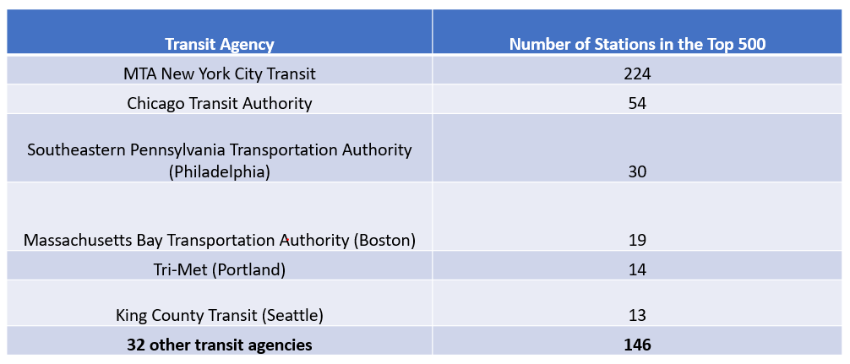

On the other hand, some stations outside of these six cities can be found amongst the top 500. The table below lists the highest scoring station outside of New York, Chicago, Philadelphia, Boston, Portland, and Seattle along with it’s rank in the Top 500 and TOD score.

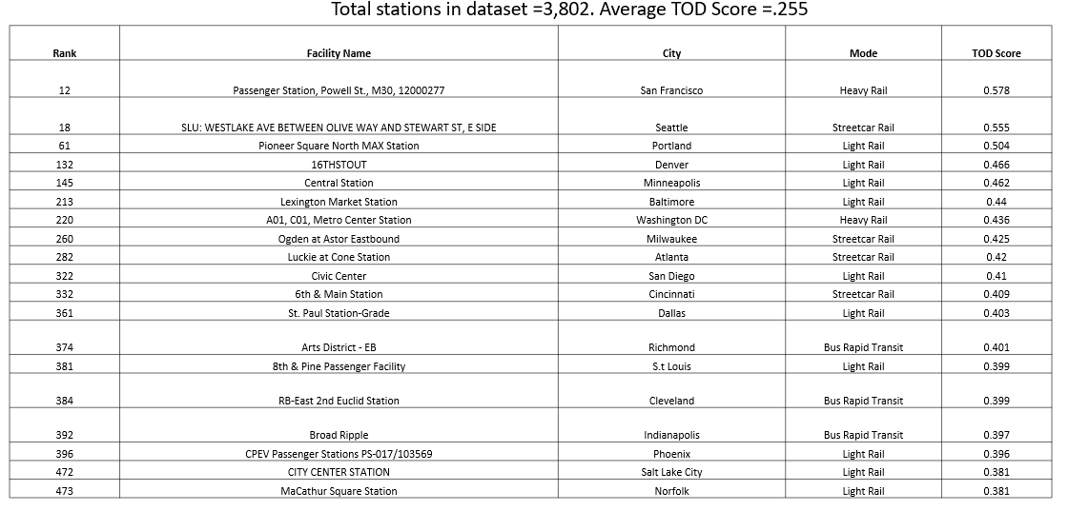

Notably absent from the top 500 are any stations in Los Angeles, the second most populous metropolitan area in the United States. The highest scoring station, highest scoring station, Memorial Park, ranks #663 out of 3,800 with a TOD score of 0.35.

**12k. Transit infrastructure features only partially explains variations in a station’s TOD score--other factors also make a difference.**

As noted earlier in this paper, heavy rail stations, underground stations, and streetcar stations are associated with greater building footrprints. Most of the stations with the highest TOD scores are located in cities with heavy rail stations many of which were built in the late 19th or early 20th century, and are often located underground or (in the case of Chicago) on elevated lines. However, linear regression reveals that transit infrastructure provides only a partial explanation of an area’s TOD score with other factors explaining the remainder of the variation.

The table below provides the results of the linear regression with the TOD score as a dependent variable. This table displays the results of the model’s forward propigation which begins by calculating the infuence of a single independent variable on a station’s TOD score and then incrementally adds features and compares performance, stopping when the performance no longer improves after additional features are added. The performance measures the Mean Squared Error, measuring the average error in the predictions, and R-squared, which shows how well the predicted values match the actual values,

For example, the model’s first iteration used a station’s mode of service (i.e. whether it served heavy rail, light rail, commuter rail, bus rapid transit, streetcar rail or hybrid rail) to predict the station’s TOD score, rsulting in san R-squared of 0.1959. This indicates that approximately 20% of the variation in the station’s TOD score can be explained by the mode of service and a large portion of the variance (80%) is due to other factors. Similarly predicting a station area’s TOD score based on the type of facility (i.e an underground, at-grade, or elevated platform station) indcates that about 25% of the TOD score can be attributed to the station type. When these features are combined (i.e. predicting TOD scores on underground-heavy rail stations vs. elevated-heavy rail stations) the R-squared increases to 30%.

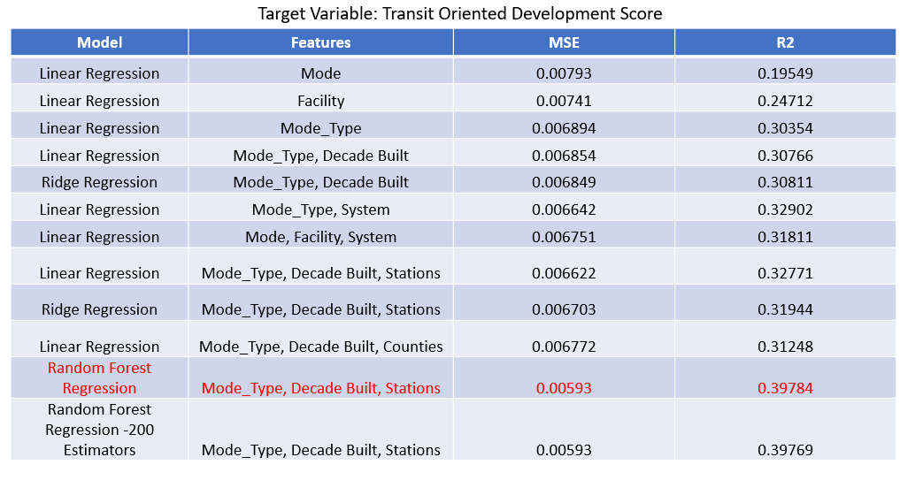

After experimenting with different machine learning models and combinations of independent variables, the most powerful model is a random forest regression that takes into account the combined transit mode and facilty type, the decade the station was built, and the number of stations in the system’s network which collectively account fo 0.39% of the variability in an area’s TOD score, leaving 60% of the variation unexplained. This suggest that factors unrelated to transit system infrastructure, such as local land use rules, public policies, economic conditions, demand for new businesses and housing, and community support or opposition have a significant effect on the extent to which an area has high amounts of TOD.

Transit planners will be reluctant to design new rail lines or station locations based on a model that predicts the variation in TOD score only 40% of the time. However, the model’s relatively weak predictive power holds a silver lining.When it comes to TOD, a station’s mode of service, station types, history, or network size is not destiny. Although older, underground subway stations in large systems are more likely to be associated with dense, walkable mixed-use communities, other factors play a significant role.

**12l. Combining TOD Features Can Identify Station Areas Ripe for Development**

Analysis that combines a station’s TOD score, TOD potential score, and TOD proximity (illustrated by the Venn Diagram below), can identify station with relatively high scores in all three categories. These station areas may be espeically prime candidates for additional development since they have a base of existing development, include some room to grow, and provide connections to multiple transit stations, modes, or systems.

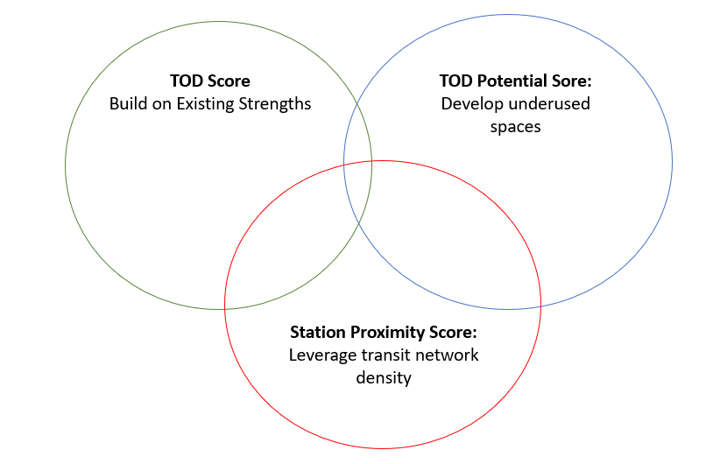

My research ranked each score and sums the three scores into a composite. Each of the three component scores have equal weight and lower scores offering greater value (i.e. it’s better to be ranked first then 500th). For example, the Marin Boulevard Station, shown below has a TOD score that ranks #395 a potential score ranked #684 and a station proximity score (or transit network score) that ranks it #240 out of approximately 3,800 stations. It’s composite score is 1319.

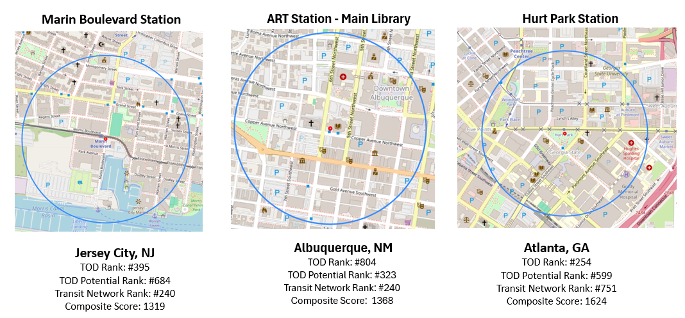

**12m. Housing around transit stations has increased and is growing fastest in least saturated station areas.**

The NoMA-Gallaudet Metro Station on the WMATA Red line opened in 2004 as Metro’s first infill station (i.e. station built between two existing stations). Six years later, a traveler arriving or leaving the station would pass by a relatively sparse amount of housing, 112 units, scattered in the surrounding blocks. But ten years after that, that there are almost 3,000 housing units around the station—a 2,534% increase and the largest percentage increase of any station in the dataset.

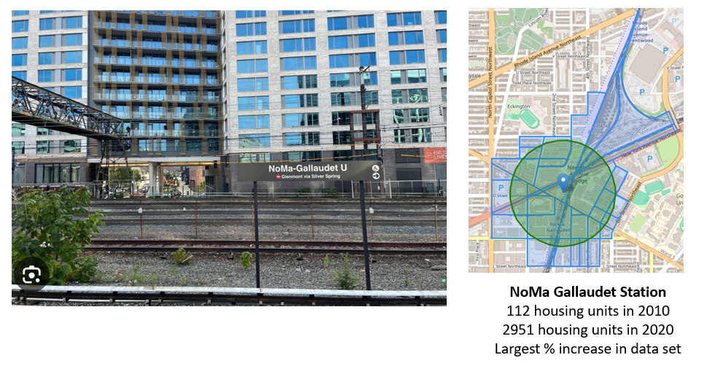

Nationally, the median number of housing units around stations increased 22% from 721 to 882 units. Without a basis of comparison, it’s difficult to determine whether housing growth around transit stations is occurring faster, slower, or about the same as housing change in neighborhoods without a station or in a city in general. However the number of housing units is highly correlated with the number of people living within ¼ mile of a station, indicating that the number of people living near transit increased as well.

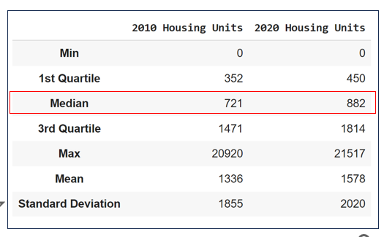 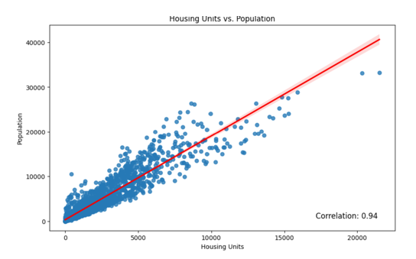

Disaggregating housing increases by transit mode, service type, and other factors reveals noticable differences in the pace of housing growth. For example, while existing housing is relatively evenly distributed amongst the six TOD market segments, housing growth occurred the slowest in the Commerical Hub or High Density residential clusters.

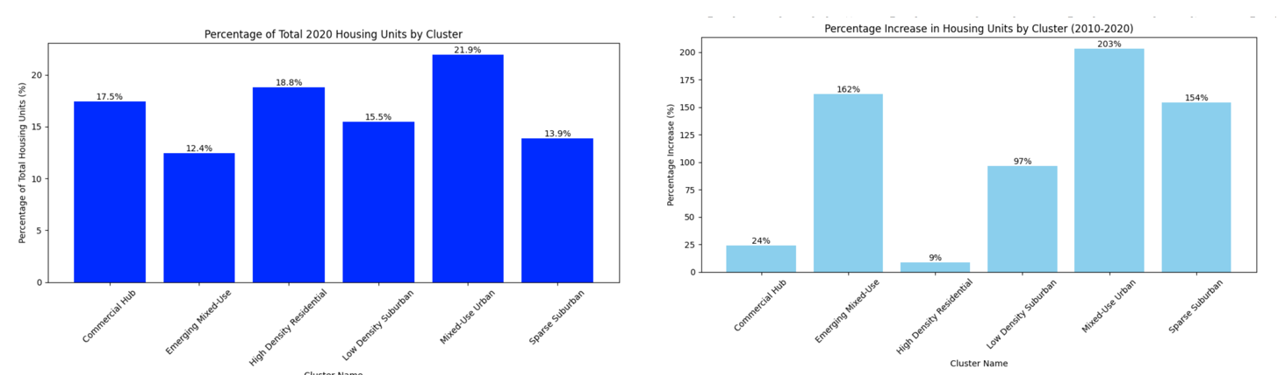

Likewise, while over 50% of the housing around all transit stations exists around stations in the Legacy Rail System Category (i.e. Boston, New York City, Philadelphia, and Chicago). Housing growth increased by 32% in this category, compared to faster growth rates in the other categories.

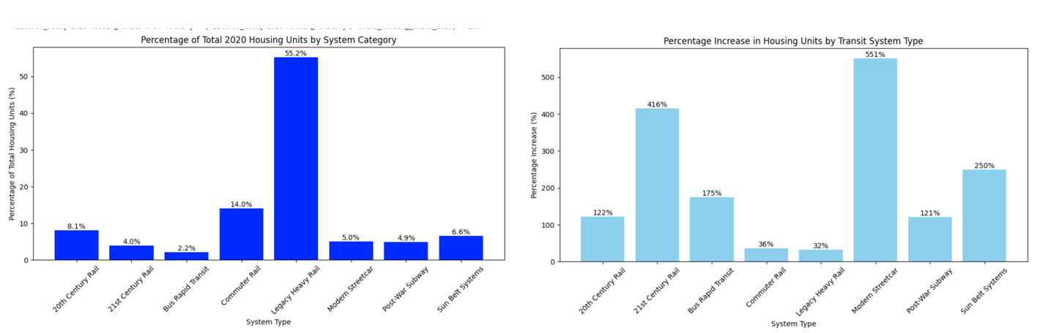

These results suggest that developers and other stakeholders working in transit stations in areas that are relatively built out have more difficulty adding new housing than those areas that are less saturated.

**12n. Housing prices around transit have increased, and TOD scores are moderately correlated with home values and rent.**

Home values and median rents are captured at the Census Block Group level which have larger geographic boundaries than Census Blocks (see Section 8e). To avoid evaluating properties relatively far away from station areas, I analyzed a subset of the TOD dataset consisting of station areas where the total block group geography was less than 4,523,893 meters, corresponding to block group geographies of ¾ mile of less (and consisting of a subset that was weighted more towards urban areas with more heavy rail and fewer commuter rail stations). The data set inluded 1,887 station areas with one or more homes and 1,910 station ares with one or more apartments in both 2010 and 2020. Per the table below, the mean home value increased 63% from $342,909 to $557,867 and and the median monthly rent increaed 48% from $1,105 to $1,668.

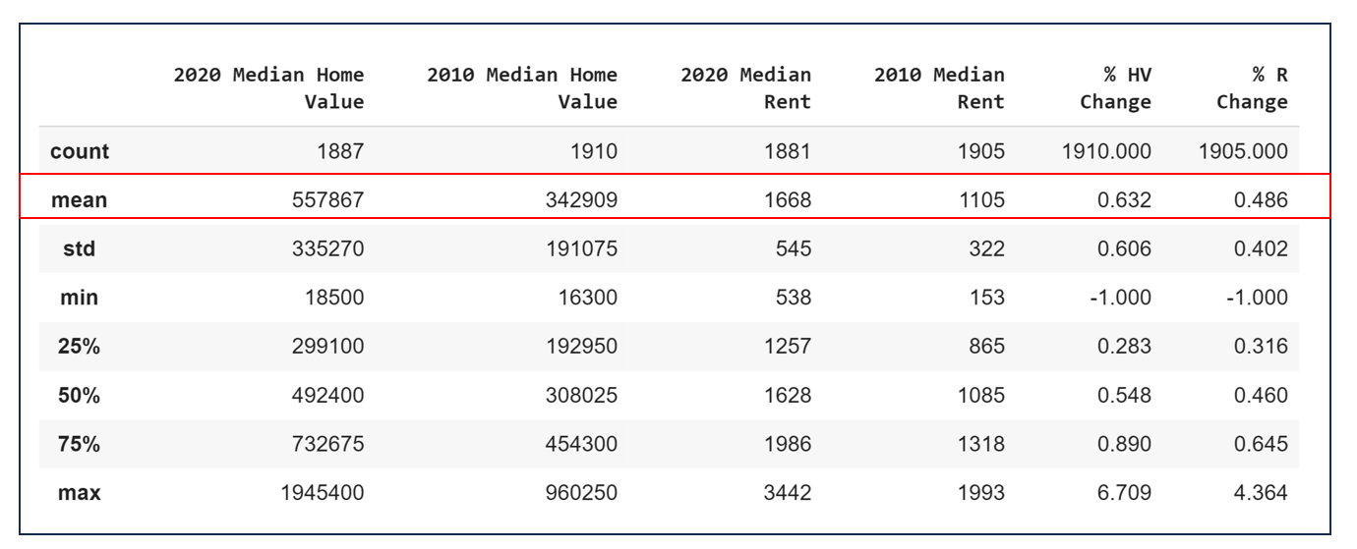

A pairwise correlation between TOD scores and 2020 Home Values and Rents indicates a moderately strong relationship between the level of TOD around a station and home value and rents in the adjoining block groups.

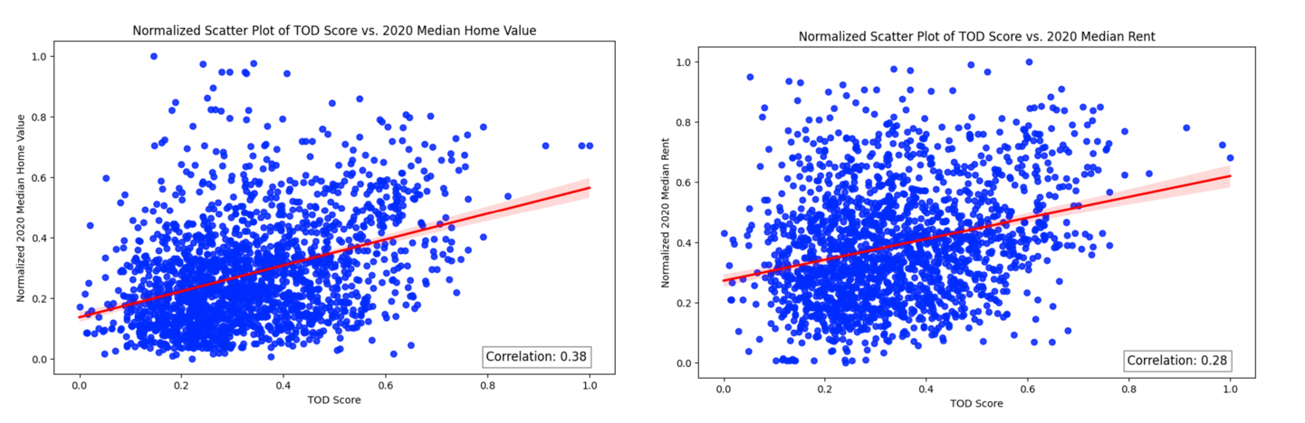

The correlation components of 0.38 for home value and 0.28 for rents mean that as TOD score increases, home values and rents increase as well but that other factors (such as the features or ages of homes and apartments, school systems, perceptions of safety) also play a role in determining property values.

Rising home values near transit and the positive correlation between TOD and property values may provide grist for TOD propoents eager to show that dense, mixed use development can increase wealth and property values and taxes. On the other hand, rising prices also raise concerns about lack of afforable housing near transit.

**12o. Transit Station Areas Have Become More Racially and Ethnically Diverse**

According to the United States Census, 61% of the population identified as “White Alone” across the United States while th nonwhite population (defined here as the number of people identifying as Black, Hispanic or Latino, Asian, American Indian and Alaska Native, Native Hawaiin Pacific Islander, two or more races, or some other race) constitued approximately 39% of the national population. In 2010 the ratio of the White to Non-Wihite population was 70% to 30%, reflecting broader changes in immigration, birth rates, and racial self identification (FN).

The population around transit stations in 2010 was generally more diverse than than the national poulation, with a mean 50/50 white non-white split. Over the course of the next decade, the nonwhite population increased to 55% of the total while the proporiton of people identifying as white alone fell to 45%.

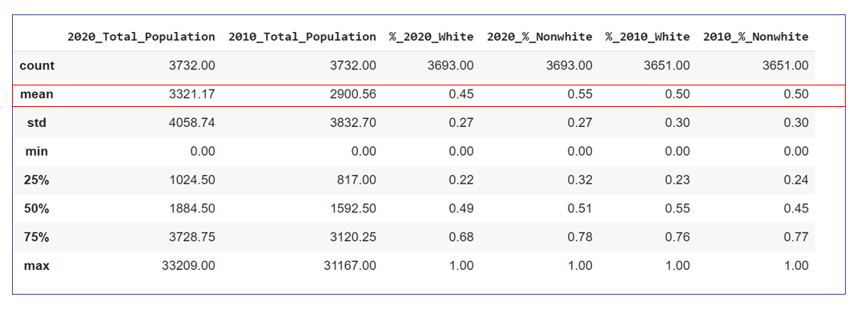

The number of racially homogenous transit station areas also fell between 2010 an 2020, though the number of station areas with predominantly white populations declined more significantly than the number of stations with predominantly non-white groups. Per the chart below, neighborhoods where the white population consisted of 80% or more existed around almost one in five stations in 2010, falling by 9.54% to less than 10% in 2020. The number of stations where the Black population was 80% or more declined only 1.2% from 4.9% in 2010 to 3.7% in 2010.

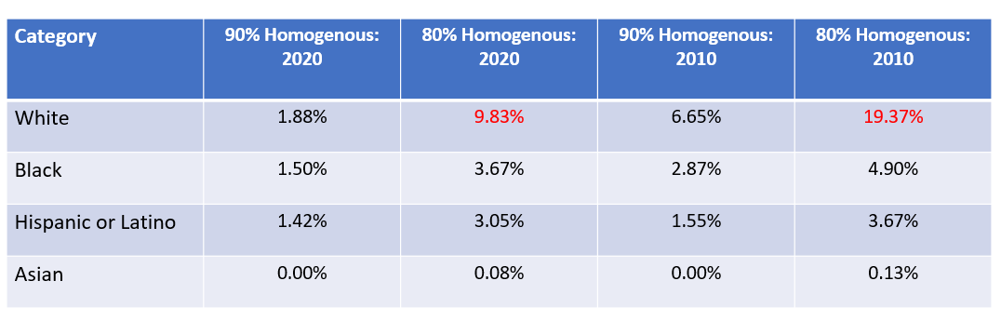

**12p. Are there differences between the racial and ethnic composition of high TOD and low TOD neighborhoods? Sometimes.**

The table below shows station areas around the Clarendon and Cheverly WMATA stations. Both are on the Orange line (and both have three syllable names that begin with the letter “C”) but the similarities end there. The Clarendon station area is a dense neighborhood with a relatively walkable street grid, multiple amenities and a retail district (shown in pink around 10th street north) and a TOD score well above the national average. The Cheverly Station is divided by a highway from a residential and industrial area (shaded in purple) with no amenities in any of the categories used in this analysis and a TOD score lower than the national average.

The Clarendon station’s population of around 5,000 people is predominantly (73%) white whereas the Cheverly station’s populaton of around 700 people is predominantly (65%) nonwhite.

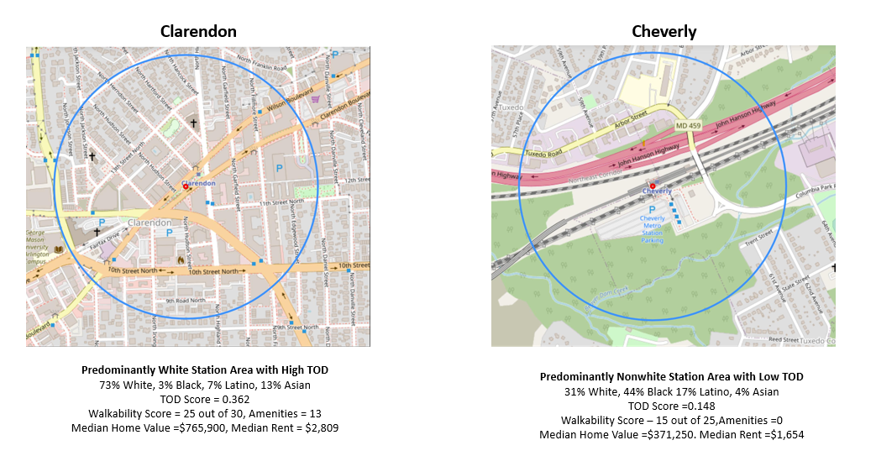

To investigate whether racial and ethnic population differences are present across stations with different levels of TOD, this project developed a correlaton coefficient matrix that pairs the percentage of the population that comprise the lagest racial groups (White, Black, Hispanic or Latino and Asian) with a station’s TOD score and related features. Correlation coefficients range from 0 to 1/-1 with a 0 indicating no liner relationship (as one variable increases or decrases, there is no pattern of change in the other variable)and 1 and -1 indicating perfect linear relationships. Per the table below, there are weak linear relationships between the White, Black and Latino population and attributes associated with TOD (TOD Score, Walk Score, Number of Amenities, and Designated Land Uses) with somewhat stronger positive correlations for the Asian population.

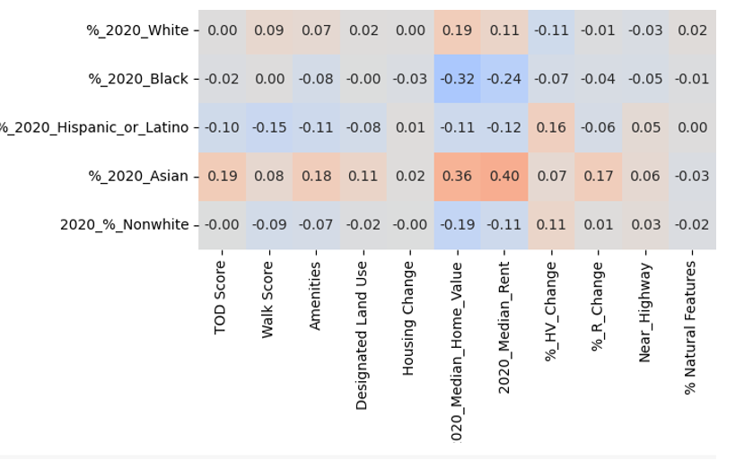

However, these relationships can vary significantly depending on the transit system. For example the correlation coefficients associated with 91 WMATA stations and 145 Chicago Transit Authority (CTA) stations indicate stronger correlations with TOD scores, walkability and the number of amenities increasing as the white population around a station increases and decreasing as the Black population increases.

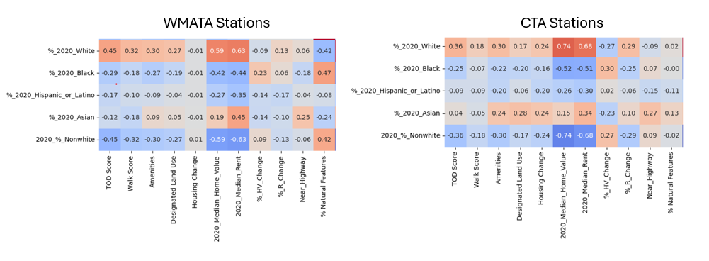

On the other hand pairwise correlation data using 46 Metropolitan Atlanta Rapid Transit Authority stations show modest but positive correlations between the Black population and TOD scores, walk scores, and amenities. The New Jersey Transit station correlation matrix (216 stations) does not reveal particularly strong relationships between the white and non-white population and elements of TOD.

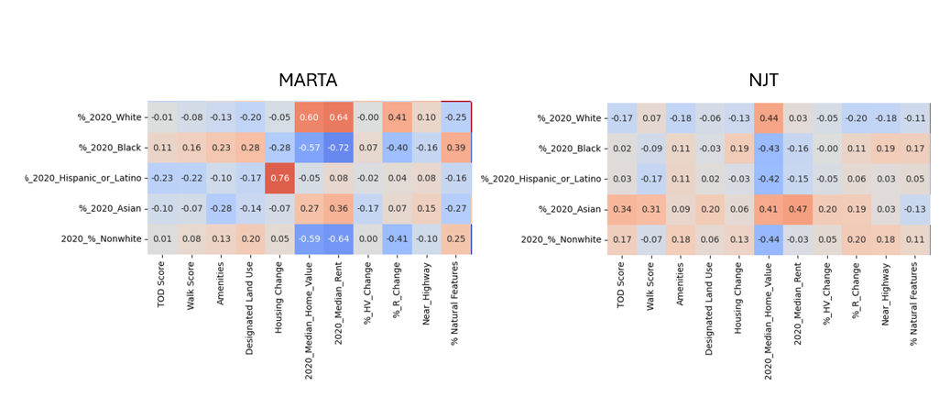

The question of why some transit systems appear to have more stark disparities between demographics and elements of TOD than others is a topic for future research. Possible reasons include the extent to which a transit system operates regionally across a geogrpahic area that has been, and continues to be racially segregated, as well as housing, land use, and transportation policies in effect at the local level.

**12q. A station area’s racial and ethnic composition influences home values and ents more than almost any other feature.**

While the relationship between race, ethnicity, and TOD varies and may not be particularly strong nationally, correlations between 2020 race and ethnicity and 2020 median home values and rents are more significant. The linear regression with recursive feature eliminaton (described in Section 11c) predicts 2020 median home values. The algorithm considerd 88 possible explanitory variables, ranging from transit modes to station types, elements of TOD and demographics, and paired them down to the eight most relevent features. Per the table below five, of the eight are associated with race and ethnicity incluidng the percent of a station area’s population in 2020 that is Asian, Black, and Hispanic or Latino and the percentage change in the black populatioin from 2010 to 2020. These features have a collective predictive power of 57%.

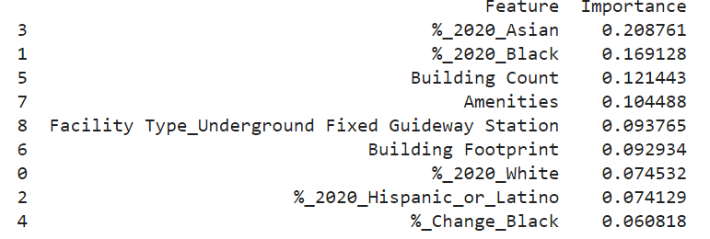

The model’s overall R-squared is 0.69, indicating that demogrpahic data as well as other features such asht the number and size of buildings and number of amenitis explains some but not all of the variation in 2020 home values. Still, the relevence of an area’s racial and ethnic composition to neighborhood home values has important implications for policymakers and others working to address disparities in the racial wealth gap.

**Further Research**

This paper analyzes data and shares insights on a topic that many people who live in cities and towns feel strongly about: the built environment and our place in it. It provides national level analysis with some examples from specific stations and cities around the United States. Stakeholders who live or work in a particular area can take advantage of the raw datasets to delve into TOD characteristics, housing, and demographics in their community. Research that introduces additional data, such as ACS data on incomes, education, family size and auto ownership may help scholars better understand communites around transit stations. Similarly, research that incorporates data at larger scales (such as citywide or countywide data) can help compare and contrast station area features against non-station areas. Additional machine learning applications could include a recommendation engine that identifies transit station that are similar to ones that are of particular interest to a user and a large language model that provides a summary of each station’s features in conversational prose. For further discussion or access to the raw data and Python code, please contact David Schneider at [schneiderd41@gmail.com](mailto:schneiderd41@gmail.com).